**Voluntary Service System (VSS) Enhancements**

**VSS*5*1**

**User Guide**



**Department of Veterans Affairs**

**Office of Information and Technology (OI&T)**

**Product Development**

**Version 2.6**

**February 2017**

**Revision History**

|  |  |  |  |
| --- | --- | --- | --- |
| **Date** | **Revision** | **Description** | **Author** |
| 02/09/17 | 2.6 | Minor changes. | VSS Technical Team |
| 01/13/17 | 2.5 | Document Review | VSS Technical Team |
| 01/03/17 | 2.4 | Document Review | VSS Technical Team |
| 12/12/16 | 2.3 | Document Review | VSS Technical Team |
| 11/03/16 | 2.2 | VSS 5*1 Additions | VSS Technical Team |
| 09/22/16 | 2.1 | Document Revised | VSS Technical Team |
| 09/13/16 | 2.0 | Document Returned | VA OIT Product Development |
| 08/31/16 | 1.9 | Document Submitted | VSS Technical Team |
| 07/06/16 | 1.8 | Document Revisions | VSS Technical Team |
| 06/02/16 | 1.7 | Document Revisions | VSS Technical Team |
| 05/18/16 | 1.6 | Document Revisions | VSS Technical Team |
| 03/09/16 | 1.5 | Document Review | VSS Technical Team |
| 02/03/16 | 1.4 | Approved Draft document | VA OIT Product Development |
| 01/26/16 | 1.3 | Updated document | VSS Technical Team |
| 01/21/16 | 1.2 | Reviewed by VA | VA OIT Product Development |
| 12/08/15 | 1.1 | Review and Update | VSS Technical Team |
| 11/24/15 | 1.0 | Initial Document | VSS Technical Team |

**Table of Contents**

1. Introduction 1

1.1 Purpose 1

1.1.1 Document Orientation 1

1.1.2 Organization of the Manual 2

1.1.3 Assumptions 2

1.2 Disclaimers 3

1.2.1 Software Disclaimer 3

1.2.2 Documentation Disclaimer 3

1.3 References and Resources 3

1.4 National Service Desk and Organizational Contacts 4

1.5 Documentation Conventions 4

2. System Summary 5

2.1 System Configuration 5

3. Getting Started 6

3.1 Screen Elements 6

3.2 Performing Tasks 7

3.2.1 Button/Link Definitions 7

3.2.2 Screen Messages 9

3.3 Logging On 10

3.3.1 SSOi with PIV 10

3.3.2 Using VA Network ID and Password 13

3.3.3 Windows Authentication 14

3.3.4 Select/Change Facility 15

3.4 Exit System 16

3.5 Automatic Timeout 16

3.6 VSS Web Home Page 17

3.6.1 Announcements 17

3.6.2 VSS Menu Bar 17

3.7 Permission Levels 18

3.8 User Access Levels 19

4. Volunteers 20

4.1 Add New Volunteer 21

4.1.1 Search for an Existing Volunteer 21

4.1.2 Create Volunteer 23

4.2 Edit Volunteer 25

4.2.1 Select Assignments 26

4.2.2 Assign an Organization 29

4.2.3 Add Parking Sticker 31

4.2.4 Add Uniform 33

4.3 Existing Volunteer Records 34

4.4 Post Regular Time 36

4.5 Post Occasional Time 39

4.6 Daily Meal Tickets 41

4.6.1 Add a Meal Ticket 42

4.6.2 Print Meal Ticket 44

4.7 Awards 45

5. Donations 47

5.1 Add New Donation 48

5.1.1 Search for Existing Donor - Individual 48

5.1.2 Create Donor- Individual 49

5.1.3 Link Volunteer 50

5.1.4 Create for Donor – Organization 51

5.1.5 Add Donation from Create Donation Screen 53

5.2 Add Anonymous Donation Screen 56

5.3 Existing Donor Records Screen 59

5.3.1 Read Only Donations 62

5.3.2 Change Donor 63

5.3.3 Merge Donor or Make Anonymous 63

5.4 Existing Donation Records Screen 65

5.5 Print Thank You Letters 67

6. Reports 68

6.1 Volunteers Reports 68

6.1.1 Meal Ticket Report 69

6.1.2 New Volunteers 70

6.1.3 View Excluded Entities 72

6.2 Donations Reports 73

6.2.1 Manage Letter Templates 73

6.2.2 Grand Total of Donations 74

6.3 Administration Reports 78

6.3.1 Address Labels Report 78

6.3.2 Voluntary Service Directory Label 81

6.3.3 National Official Labels 83

7. Maintenance 84

7.1 Manage Facilities 84

7.2 Manage Organizations 89

7.2.1 Create/Update Local Branch 95

7.3 Search Existing Organizations 95

7.4 Manage Voluntary Service 96

7.4.1 Create and Manage Voluntary Service Staff 97

7.5 Manage Benefiting Service 98

7.6 Manage Service Templates 100

7.7 Manage Volunteer Requirements 101

7.7.1 Both Administrative Roles 102

7.8 Manage Staff Titles 104

7.9 Manage Award Codes 105

8. Reference 107

8.1 Policies 107

8.2 VAVS SharePoint 108

8.3 VAVS Website 108

9. Manage User Access 108

9.1 Manage User Access 109

9.1.1 Select User 109

9.1.2 Assign Roles and Facilities 109

9.1.3 Unlock User 110

9.1.4 Time Zone 110

10. Help 111

11. Troubleshooting 111

11.1 Special Instructions for Error Correction 111

12. Acronyms and Abbreviations 112

13. CRUD Matrix 113

14. Appendix A: Stakeholders, Users, and Workgroups 113

# Introduction

The Department of Veterans Affairs (VA) Voluntary Service (VAVS) operates one of the largest volunteer programs in the Federal Government, supplementing staff and resources in all areas of patient care and support. VAVS’s mission is to provide a structured volunteer program under the management of VA compensated employees in cooperation with community resources to serve Veterans and their families with dignity and compassion.

The Voluntary Service System (VSS) is an Enterprise web application that allows staff to track volunteers, assignments, schedules, hours, and the affiliated organizations. The VSS Enhancement project tracks donations and provides information on volunteer data for a variety of purposes. As mandatory requirements for on-boarding volunteers (including security) increase, significant improvements are needed to meet these demands.

The term “user” throughout this document refers to Voluntary staff members, not actual volunteers.

** This User Guide was drafted in a test environment and therefore the data is not active.**

## Purpose

The purpose of this VSS Enhancements User Guide is to provide summaries and step-by-step instructions for all VSS user screens. The intent of this document is to familiarize users with the functionality released with VSS*5*1.

The VSS User Guide is a reference manual used in conjunction with the online help in the VSS application. The User Guide provides an overview similar to the online with the steps and procedures in a print form.

In addition, VAVS staff uses VSS to track the thousands of volunteers used for the national rehabilitation events. The VSS User Guide may be accessed on-line through the Vista Documentation Library (VDL) at the following address: <http://www.va.gov/vdl/application.asp?appid=135>

* **This guide only includes what is completed through the most current Software build in Production. Future functionality is captured and provided at a later date**.

### Document Orientation

The VSS User Guide and Artifact Repository for VSS can be accessed through the following link: <http://www.va.gov/vdl/application.asp?appid=135>

### Organization of the Manual

Future updates to this document include sections corresponding to the different organizations that use the VSS application; Central Office (CO), the Enterprise Management Center (EMC), and the Voluntary Service Timekeeping stations.

The full VSS Menu includes the following areas of functionality.

* + - 1. Volunteer Records - for viewing and editing Volunteer master records.
      2. Time Posting - for recording hours of regular and occasional volunteers.
      3. Awards - for issuing awards to volunteers.
      4. Donations - for tracking donations to a Veterans Health Administration (VHA) facility.
      5. Reports - for generating reports on various aspects of a facility’s activities and personnel.
      6. Maintenance - for tailoring the VSS application to a site's needs (e.g., entering local services, organizations, and programs).
      7. Reference – for accessing important links, policies, procedures and other publications directly from VSS Web.
      8. User Administration - for viewing and assigning security roles to system users.

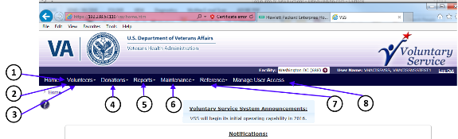

### Assumptions

This Guide includes the following assumptions:

* + - 1. VSS*5*1 incorporates Standard Data Services lookup tables so that all current sites such as the Veterans Integrated Service Network’s, Veterans Affairs Medical Center’s, and Community Based Outpatient Clinics (CBOCs) are available for users and updated periodically.
      2. Military time is the standard for user interface (UI) input; the user may have the ability to set preferences which customizes the output display.
      3. All times entered and displayed are in the user’s local time zone, which is synchronized when the user logs into the application.
      4. The VA standard inactive period of 15 minutes applies to this system, and the user is automatically logged out unless they choose to remain active. The VSS application (and its interfaces) is running on the most current platform supported by OI&T.
      5. The Structured Query Language (SQL) Extensible Mark-up Language 3.0 functionality is replaced. According to Enterprise Operations (EO), when users are moved off of the SQL Server 2008 to SQL Server 2012, the functionality is not supported.

## Disclaimers

### Software Disclaimer

 *This software was developed at the Department of Veterans Affairs (VA) by employees of the Federal Government in the course of their official duties.*

*Pursuant to title 17 Section 105 of the United States Code this software is not subject to copyright protection and is in the public domain.*

*VA assumes no responsibility whatsoever for its use by other parties, and makes no guarantees, expressed or implied, about its quality, reliability, or any other characteristic. We would appreciate acknowledgement if the software is used.*

*This software can be redistributed and/or modified freely provided that any derivative works bear some notice that they are derived from it, and any modified versions bear some notice that they have been modified.*

### Documentation Disclaimer

*The appearance of external hyperlink references in this manual does not constitute endorsement by the Department of Veterans Affairs (VA) of this Web site or the information, products, or services contained therein.*



*The VA does not exercise any editorial control over the information you may find at these locations. Such links are provided and are consistent with the stated purpose of the VA.*

## References and Resources

* + - * VHA Forms and Publication Search page <http://vaww.va.gov/vapubs/search_action.cfm?dType=2>
      * Handbook 1620.01 Voluntary Service Procedures <http://vaww.va.gov/vhapublications/ViewPublication.asp?pub_ID=2165>
      * Handbook 1620.02 Volunteer Transportation Network <http://www.va.gov/vhapublications/ViewPublication.asp?pub_ID=3042>
      * VA Handbook 6500 – Information Security Program [http://vaww.va.gov/vapubs/viewPublication.asp?Pub_ID=793&FType=2](http://vaww.va.gov/vapubs/viewPublication.asp?Pub_ID=793&amp;FType=2)
      * Handbook 4721 VHA General Post Fund Procedures <http://vaww.va.gov/vhapublications/ViewPublication.asp?pub_ID=1571>

## National Service Desk and Organizational Contacts

|  |  |  |  |
| --- | --- | --- | --- |
| **Name** | **Role** | **Organization** | **Contact Info** |
| OI&T National Service Desk | Tier 1 Support | OI&T | 1-855-673-4357 |
| Financial Systems Team | Tier 2 Support | OI&T | 1-855-673-4357 |
| Health Product Support | Tier 2 Support | VHA | 1-855-673-4357 |
| Vista Patch Maintenance | Tier 3 Application Support | OI&T | 1-855-673-4357 |

## Documentation Conventions

The VSS Development Team adheres to the documentation requirements as required by VIP in compliance with VA and Product Development documentation standards.

| **Symbol** | **Description** |
| --- | --- |
| Caution symbol | **CAUTION or DISCLAIMER:** Used to inform the reader to take special notice of critical information. |
| Default Station icon. | **Default Station icon** - Clicking on this icon displays a dialog box that allows you to specify which station's data is the default station data when you start or restart the application. |
| Drill Up icon. | **Drill Up icon-** Allows the user to navigate “up” the group tree. |
| Drop-down arrow icon. | **Drop down arrow icon -** Located next to the page text box allows users to navigate to the first and last page of the report. |
| Edit icon. | **Edit -** Edit button is used to view or change information in an existing record |
| Export icon. | **Export icon -** Used to export reports. The Export dialogue box provides typical export options. |
| Help icon. | **HELP Icon -** Clicking on this icon displays the **Help** page explaining how to use the screen you are on. |
| Note or Reference icon. | **NOTE or Reference:** Used to inform the reader of general information and reference material. |
| Page Navigation icon. | **Page Navigation icon -** Used to navigate through pages of a report |
| Print icon. | **Print icon-** Provides print operation options. Select your printer from the **Printer** drop down and click the **Print** button to print a copy of the report |
| Refresh icon. | **Refresh Report** icon- Used to refresh the report. |
| Text box icon. | **Text box icon -** Navigates to a specific page. Enter the page number into the text field and press Enter. |
| Zoom field icon. | **Zoom field icon -** Shows the current zoom and allows user to zoom in or out on the report. Clicking the dropdown icon provides quick options for users; however, any zoom amount can be entered manually. |

# System Summary

VSS is an Enterprise web application that tracks volunteers, their assignments, schedules, hours, and their affiliated organizations. The new VSS enhancements track donations and provide information regarding volunteer data for a variety of purposes. For additional VSS information, refer to the Table below.

|  |  |
| --- | --- |
| **VSS System Information** | |
| **System Name:** | Voluntary Service System v5*1 |
| **System Type:** | Enterprise Web Application |
| **Hosting Type** | Enterprise Operations Managed |
| **Information Security Officer:** | Robert Caldwell, [Robert.Caldwell@va.gov](mailto:Robert.Caldwell@va.gov) |

## System Configuration

New system features proposed for the VSS Enhancements project are categorized as functional or non-functional.

Functional requirements represent new features or functions requested by the business. Non- functional requirements represent documentation, disaster recovery, 508 compliance, security, and system performance requirements.

# Getting Started

Over 80,000 volunteers contribute more than 11 million hours of service to Veterans annually. Currently, VSS does not support the ability to categorize this volume of volunteers. Due to increased demands for on-boarding security checks, health screenings, and training, VSS enhancements reduce administrative overhead by automating tracking, and notifying VAVS Program Managers when mandatory requirements have been met.

## Screen Elements

VSS uses a graphical User Interface. Screen access is limited by the system role assigned (user, manager, or administrator) and by the type of site you belong to: the CO, EMC, Game station, or Timekeeping station. Common screen elements include the following:

Data Grids used throughout this document include:

**Filter Functionality:** Allows you to enter a value or partial value, such as a Name or Abbreviation, to filter through or the ability to display values in ascending and descending order.

**Search Button:** Searches for the criteria entered in the text fields (i.e., Name or Abbreviation in the example below) and displays a list of results that match the criteria.

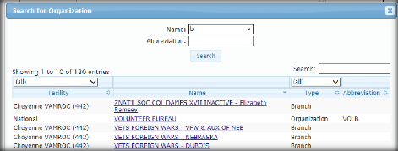

The Search text field enables you to search for any value in the results, narrowing down a match quicker on the Search box. This search is executed against all information currently being displayed in the list.

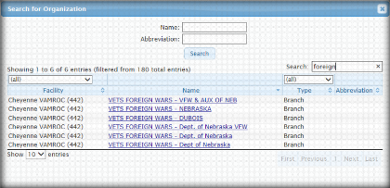

**Field:** Used for entering text or numbers.

**Dropdown or Pulldown List**: Some options are available in a dropdown list. When you click on the option, the list expands and then select the option you want. If the list is long, click on the up or down arrows on the bar to scroll through the list.

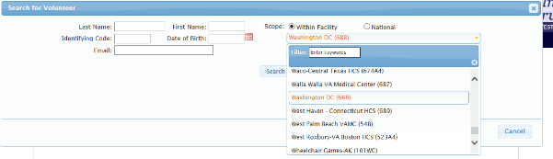

**Radio Button:** Radio buttons are options, one of which can be selected.

## Performing Tasks

Most of the work performed in VSS is done with buttons and links. The function of a button is indicated in its name. Links are actions that navigate you to screens. For example, a click on this button will search for an existing volunteer.

A graphic of the Search for Existing Volunteer button.

### Button/Link Definitions

**Activate** - The Activate link is used in specific screens and initiates an action. This volunteer has at least one active assignment at any facility.

**Add** - The Add link is used to add a new item to a list or to the database.

**Advance Page** -The Advance Page is an option to direct users to a specific page (s) (i.e., First, Next, and Last).

**Assign/Assignment** - Used for posting or assigning.

**Cancel** **-** The Cancel link exits the screen and returns you to the previous screen without saving the information.

**Clear** - The Clear button is used to erase entries or reset fields on a screen. It is not used to remove data from the database.

**Close -** The **Close** link closes a screen or popup window.

**Delete** - The **Delete** link is used to remove a record from the database.

**Display** - After specifying what to include in a report, the **Display** button enables you to see the report on the screen.

**Edit** - The **Edit** button is used to view or change information in an existing record.

**Excel**, **PDF**, and **Print-** The options are for creating documents or printing.

 When using Internet Explorer to print, the user must manually set the print option to **landscape** for reports or data grids to include all content. Export options for Word/PDF to landscape can be controlled by the system.

**Exit -** The **Exit** button takes you to the opening of the VSS screen where the station dropdown list is located. In multiple screen tasks, the Exit button takes you back to the previous screen or the first screen in the process.

**Inactive** - **Inactive** status does not have any active assignments at any facility. A volunteer that stops volunteering at one location should not be prevented from volunteering at another facility. The Volunteer should have all their assignments set to inactive – the volunteer should **NOT** be terminated.

**Log in -** The user role(s) depends on how a user can **log in** to VSS. An administrator must grant access for 1 or more VSS user access roles and applies to 1 or more facilities per user.

**New** - The **New** link is used when creating a new record in the database such as a new program, service code, volunteer, etc.

**Next** - When there are multiple screens for performing a particular task, the **Next** button navigates a user to the next screen in the sequence.

**OK** – The **OK** status is action confirmation.

**Select** - **Select** represents a pending action, choice, or decision.

**Submit** –The **Submit** button sends modified or new information to the database, or navigates the user to another screen.

**Terminate -** A volunteer termination would happen in rare instances and should be reserved for situations when it is known the volunteer will not return or should not return. For example, the volunteer has passed away or has been deemed unfit for service for health or minor behavior issues. To terminate a volunteer, select the **Terminate** button. A termination date is required. Termination date cannot be prior to the current date or on a date that the volunteer has time logged. For example, if a volunteer is to be terminated today but has accrued volunteer hours, the termination date must be the following date.

**Terminated With Cause -** If a volunteer is to be terminated with cause, meaning there is a more serious reason to terminate their engagement, for example, abusing a patient, stealing, etc., select the Terminate with Cause check box. Only a person with site or national administrator rights can clear a termination with cause. In both instances, a comment is recommended.

### Screen Messages

The next Table reflects some of the VSS Screen messages that the user sees throughout the system.

|  |  |
| --- | --- |
| **Screen** | **Message** |
| **VSS Invalid Login Page Message** | *“Sorry, the login credentials are invalid.”* |
| **Account Lock Message** | *“Sorry, your account is locked. Please contact your VSS Administrator or wait 15 minutes for your account to unlock.”* |
| **Inactivity Message** | *“You will be logged off in 13 seconds. Do you want to continue?”* |
| **Confirmation Message** | *“Yes, keep working,”* |
| **No Results Found** | *“Sorry, no volunteers were found that matched the specified criteria.”* |
| **Organization exists as a Donor** | *“Organization is linked to another donor. Please select a different organization or search for the donor record established for this organization.”* |
| **Logout** | *Changes that are not saved will be lost! Do you want to logout?* |
| **Search for Volunteer** | *“Please enter at least one piece of search criteria”* |
| **Edit Volunteer** | *“A volunteer was created successfully.”* |
| **Create Volunteer** | *“Please fix the errors below.”* |
| **Donor is linked to a volunteer** | *“Volunteer is linked to another donor. Please select a different volunteer or search for the donor record established for this volunteer.”* |
| **Add New Volunteer** | *“Please search for an existing volunteer before adding a new one.”* |
| **Organization Detail** | *“The organization was created successfully.”* |
| **Remove National Official** | *“Record Deleted"* |
| **Error Message/Attention** | *“Attention, Please correct the following errors.”* |
| **Add New Donation** | *“Please search for an existing donor before adding a new one.”* |
| **Search for Donor** | *“Sorry, no donors were found that matched the specified criteria.”* |
| **Create Donor** | *“Are you sure you want to remove the volunteer link from this donor?*” |
| **Edit Donor** | “*The donor was created successfully.”* |
| **Create Donor** | “*Your search exceeded the maximum results. Please enter additional search criteria.”* |
| **Reports** | *“Please enter a value for parameter, Organization, Sort By, Type or Email Option.”* |
| **Organization Donor Type** | *“Organization is linked to another donor. Please select a different organization or search for the donor record established for this organization.”* |
| **Daily Meal Tickets** | *“Sorry, no meal ticket found that matched the specified criteria.”* |

## Logging On

Users can access VSS using a web browser via single sign-on capabilities. Single Sign-On Internal (SSOi) is an authentication service provided by Identity Access Management (IAM) and designated for operations-based applications such as VSS.  This service provides an extra layer of security when accessing the application, while reducing time associated with multiple logon/logoff activities. A PIV card is required, unless an exception to use VA User Credentials is allowed.

* Upon successful login, the user is directed to the **Select/Change Facility Screen** or to the **VSS Web Home Page**.If a user is assigned to multiple facilities and has not yet selected a default facility, the user must select the appropriate facility before proceeding.
* Refer to **Select/Change Facility** section for additional information. If a user is only assigned to one facility, the **VSS Web Home Page** displays for that facility. Once a user has selected the default facility, the **VSS Web Home Page** displays it. The system then uses this Facility in all subsequent functions.

### SSOi with PIV

* + 1. Ensure your PIV card is inserted in the card reader.
    2. Using the web browser, access VSS through URL: https://vaww.vss.med.va.gov/
    3. The **VA Single Sign-On Screen** displays. Click **Sign In with VA PIV Card**.
* If the **VA Single Sign-On Screen** is notdisplaying using Internet Explorer, ensure SSL 2.0 and SSL 3.0 are unselected in the browser security settings. In your browser's top right corner, click the **Tools** icon and select **Internet Options**. Click the **Advance** tab and ensure the options are unselected.

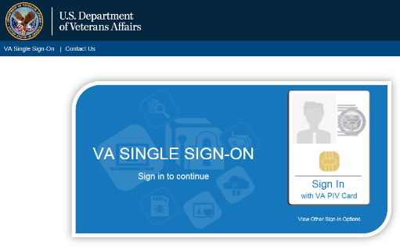

* + 1. The system will verify and read the PIV card. If found, the **Windows Security** box displays with the list of certificates associated with the PIV card.
    2. Select the **certificate** and click **OK** to display **the ActivClient Login** window.

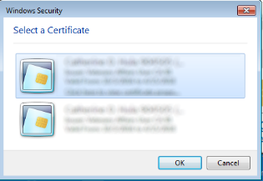

* + - * If more than one certificate displays, select **Click here to view certificate properties** link to display the **Certificate Details** box. Select the Certificate Path tab and scroll to ensure the certificate ends **internal PIV Authentication**.

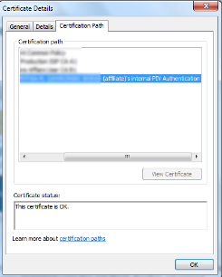

* + 1. Enter your **Pin Number** and click **OK**.
  + If the incorrect Pin Number is entered, an error message displays and the user has six more attempts before being locked out and will need to be unlocked by calling the VA National Service Desk at 1-888-596-4357.

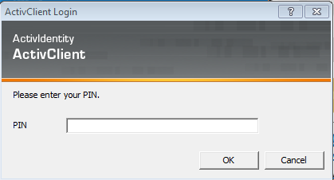

* + 1. Once the system verifies the PIV card and Pin Number match, the **Select/Change Facility** **Screen** displays or the **VSS Home Page**.
  + If the user is *only* authorized to a single facility, the system defaults to the authorized facility. The user does not have to select it upon login. The System recognizes this access and uses the selected facility in all subsequent functions
  + If the user is authorized to access multiple facilities:
    - If the user has previously selected a default facility, the user does not have to select a facility upon login. The system defaults to the specified default facility and uses this facility in all subsequent functions. To change the facility, click the **Facility name link** in the header bar to display the **Select/Change Facility** page

### Using VA Network ID and Password

In some cases, a user may sign-in with their **VA Network Username** and **Password**. This is only to be utilized when a PIV exemption is required. User must call VA Help Desk and request this exemption for this option to be utilized

* + 1. On the **VA Single Sign-On Screen**, click the **View Other Sign-On Options** link to display the **VA Single Sign-On** box.

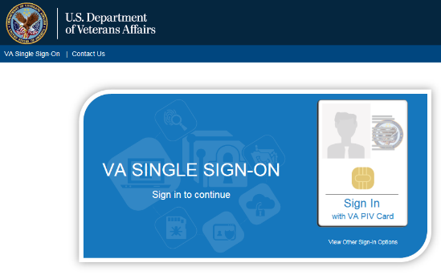

* + 1. Click **Sign in with** **VA Network ID**.

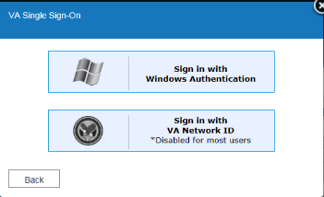

* + 1. **The VA Single Sign-On** box displays text boxes to enter your **VA Network ID** and **Password**. Click **Sign-In**.

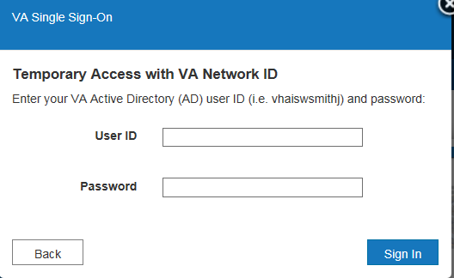

* + 1. The system will verify the user and be redirected to the **Select/Change Facility Screen** or the **VSS Home Page**.

### Windows Authentication

* + 1. On the **VA Single Sign-On Screen**, click the **View Other Sign-On Options** link to display the **VA Single Sign-On** box.



* + 1. Click **Sign in with Windows Authentication**.



* + 1. The system will verify the user and be redirected to the **Select/Change Facility Screen** or the **VSS Home Page**.

### Select/Change Facility

If a user is authorized to work at multiple facilities and the user has not yet selected a default facility, the **Select/Change Facility Screen** displays after login. This screen displays a list of authorized facilities and can be accessed at any time by authorized users. If the user does not have a default facility on file, the system recalls the last facility visited and highlights that facility the next time the user logs in.

 VSS utilizes user access roles to control access to application functionality (Facility).

* + - 1. From the **Select/Change Facility Screen**, select the appropriate facility from the list to access VSS Web (Example: Cheyenne VAMC (#442) in the **screenshot** below is selected).
      2. Click on the **up** or **down** arrows on the scroll bar to scroll through the list. To filter through the list, enter the three digit facility code or any part of the facility name in the **Select Facility** text box.
      3. For an easier selection, the last facility accessed is highlighted in the **Select Facility**

list.

* + - 1. Click **Submit**.

Additional information that displays on the screen includes:

* Last Facility Visited:
  + Name: In this example, Cheyenne VA Medical
  + Parent: Veterans Integrated Service Networks (VISN)
  + VISN: 19VA VHA is divided into 21 geographical regions or areas called VISNs. In this example VISN 19 represents the VA Rocky Mountain Network.

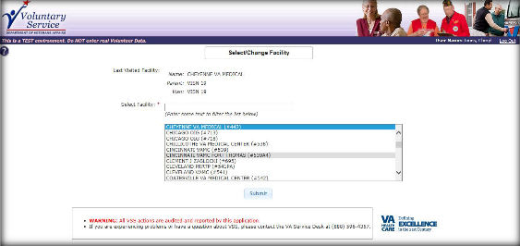

## Exit System

The User must click the **Log Out** link located above the **VSS Menu Bar**. A confirmation message is displayed, click **OK** to confirm.

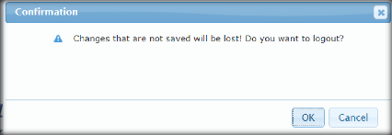

Once confirmed, the user is logged out of VSS and returns to the **Login** page. User may exit their web browser once logged off. If not confirmed, the system returns to screen displayed, when logout was requested.

## Automatic Timeout

The user is automatically logged out of the system after 60 minutes of inactivity. A warning message displays, counting down from 30 seconds until a user is logged off the application. A user may click the **Yes. Keep Working** button to stop the countdown and continue working. If the system automatically logs off, any work in progress is not retained. User will have to login again using SSOi with their PIV card and PIN or other options.

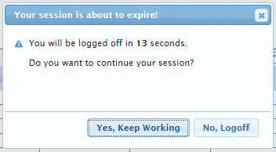

## VSS Web Home Page

The **VSS Web Home Page** displays once the user is successfully logged in. From the home page, the user can access VSS functionality using the menuoptions, based upon the access role assigned.

 The example displayed in the next Figure is a Test Environment Banner and will not be seen in Production.

* + - The **Facility Name** and **Facility Number** that the current user is working in is displayed in the header.
    - The **User Name** is displayed in the top right corner of the application header.
    - The **Log Out** link is available to exit VSS.
    - The Footer section is the area at the bottom of VSS application screen. The section contains an audit message, contact information for questions or problems, application version, and copyright date.

### Announcements

Any important program announcements will display in the **Announcements** box.

### VSS Menu Bar

The **VSS Menu Bar** at the top of the screen allows access to functions that a user can perform, according to role assigned to the user. Example 1 in the **Figure** refers to the **VSS Menu Bar**.

**Breadcrumb Link** - As a user navigates back and forth through the application, the names of screens display at the top left of the screen. A user can click the **Breadcrumb link** and go to that location. Example 2 in the **Figure** refers to the **Breadcrumb link**.

**Help** – Clickingthe **Help** icon **Help icon** on each screen displays the **online help page** that is specific to that screen. A user can access the online help for step-by-step procedures on how to utilize the functionality of VSS. Example 3 in the **Figure** 3 refers to the **Help** icon.

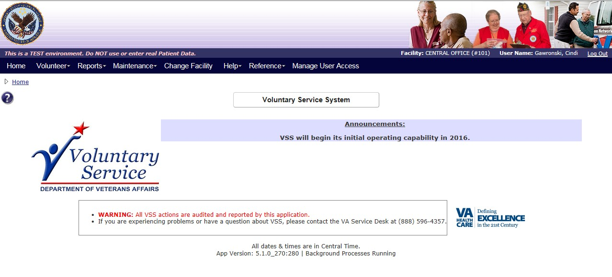

## Permission Levels

VSS application utilized by the Voluntary Service Office staff utilizes an access role granted to the user for each facility to control access to application functionality. Each user access role has a set of predefined permissions associated with it and the user **must** be assigned a user access role before using the VSS application.

The next **Figure** represents the Permission Hierarchy for VSS. The National Administrator is the highest level and is responsible for nationwide VSS administration. This includes granting all levels of user access and maintaining all national lists and reports.

For more information on the access roles, refer to the CRUD Matrix in section 13 within this document.

**Figure 3: Permission Hierarchy**

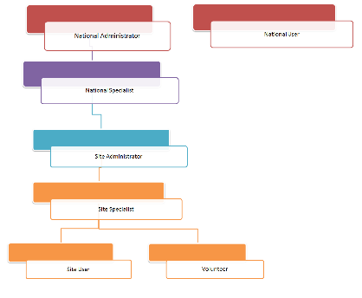

## User Access Levels

VSS is designed for primary and secondary users to easily track volunteers, assignments, schedules, hours, and their affiliated organizations as described in the next table.

|  |  |  |
| --- | --- | --- |
| **Type of User** | **Description** | **Responsibilities** |
| Primary Users | Voluntary Service Staff | ~~•~~ Volunteer Management, Timekeeping, and Donation Tracking. |
| Primary Users | National Administrator | * Voluntary supervised programs; tracks Voluntary Services at all VHA facilities. * Creates basic information for new VHA sites or edits information for existing sites. The station information resides in the institution file. * VSS National Administrator shall have the ability to update/edit National Advisory Committee (NAC) information. |
| Secondary Users | Volunteers (contractor or employee) | * Take mandatory training, transport patients, work with Veterans at the National Games, and other volunteer duties, including entering their time and printing meal tickets, when applicable. |

# Volunteers

Users with the following roles are permitted to use the **VSS Volunteers Menu** option.

* **National Administrator (Only if logged into a local facility)**
* **National Specialist (Only if logged into a local facility with Read Only access)**
* **Site Administrator**
* **Site Specialist**
* **Site User (Read Only access)**

From the **VSS Menu Bar,** select **Volunteers.** The following dropdown options are listed:

* **Add New Volunteer**
* **Existing Volunteer Records**
* **Post Regular Time**
* **Post Occasional Time**
* **Daily Meal Tickets**
* **Awards**

**Names used throughout this document in the screenshots are examples only and are not valid names.**



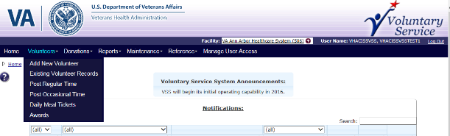

## Add New Volunteer

With the appropriate permissions assigned, you can add a new volunteer to the VSS application. But first, you must perform a search to verify if the user exists in the database.

The high-level process for creating a new volunteer is:

* + - From the **Volunteers Menu**, select **Add New Volunteer** to display the **Add New Volunteer Screen**.
    - Search forexisting volunteers thoroughly to ensure a duplicated **Volunteer Profile** is not created.
    - If a volunteer is not found, the **Add New Volunteer** button is available to create the new volunteer profile.
    - Use the **Edit Volunteer Screen** to Add Assignments and Organizations. A volunteer cannot log in or get meals without at least one active Assignment and one active Organization.

### Search for an Existing Volunteer

Searchable Fields for **Add New Volunteer**

1. **Name -** Last Name, First Name, Middle Name or Suffix.
2. **Scope -** National is selected, locked, and is the only selection for adding a new volunteer.
3. **Identifying Code (IC) -** The user’s sign-in code and is based on when the volunteer was added. The IC is alphanumeric. In the example below, L represents letter. N represents number.
   * + - Existing users IC’s remain (i.e., LNNNN).
       - For users that previously had duplicate IC’s, the user with the oldest entry will keep the original IC. The other users will have an extra number at the end of their original IC (i.e., LNNNNN).
       - New user IC’s are randomly assigned a 6 digit code that is 3 letters and 3 numbers (i.e., LLLNNN).
       - **Date of Birth (DOB):** Calendar displayed:
       - If the user clicks on the calendar, the current month displays with the current year. You can change the information by entering the 2 digit month, 2 digit days, and 4 digit years.
       - Another option is to use the forward and backward arrows to select the month and date, and enter the 4 digit year.
       - When using accessibility tools, the user can directly type in the date.
       - **Email Address:** Optional; Searchexisting volunteers by matching the email address.
       - **Include Inactive Volunteers:** This option is selected and locked. When adding a new volunteer a user must view all “*Inactive Volunteer*” matches in the **Search** to help avoid duplicating an existing volunteer.

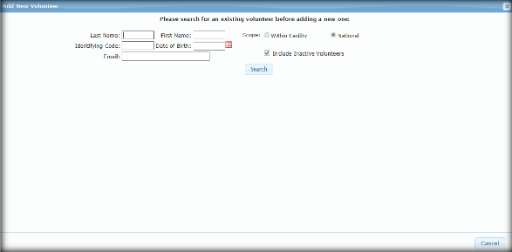

* **Conduct a thorough *Search* to prevent the creation of duplicate volunteers.**
  + 1. Enter at least one piece of Search criteria. If the user clicks **Search** without making a selection, a pop-up message displays, *“Please enter at least one piece of search criteria”.* After viewing the message, **close** the screen.

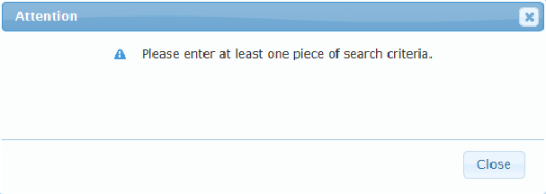

1. If no information appears from the name *Search* a message displays, *“Sorry, no volunteers were found that matched the specified criteria.”* The user then has the option to click the **Add New Volunteer**button.

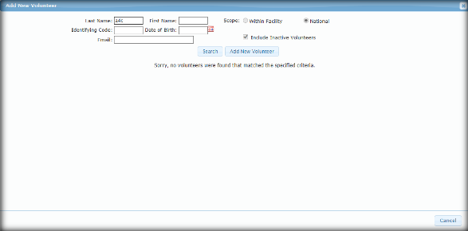

### Create Volunteer

Within the **Create Volunteer Screen** are multiple panels representing different functional aspects of the volunteer. The panels shown may vary depending on your screen’s zoom range, and may show more than one column.

**Volunteer Name**

* + - * Last Name (required)
      * First Name (required)
      * Middle Name
      * Suffix

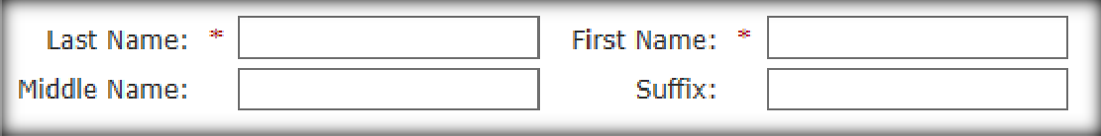

**Master Record**

* + - * Nickname
      * Gender (required)
      * Date of Birth (required)
      * Preferred Language
      * Code
      * VA employee check box
      * Remarks box

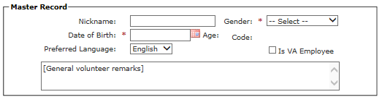

**Contact Information**

The **Contact Information** is the Volunteer’s demographic data updated by the user.

* + - * Address Line 1 **(**required)
      * Address Line 2
      * City (required)
      * State (required)
      * ZIP Code (required)
      * Email
      * Phone
      * Alternate Phone 1 and 2

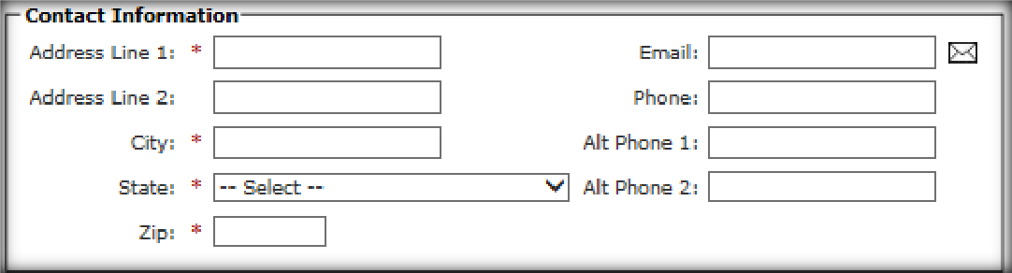

**Emergency Contact**

The **Emergency Contact** is the volunteer’s family contact information used in case of an emergency.

* + - * + Name
        + Relationship
        + Phone
        + Alternate Phone

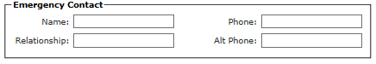

**Facility Management**

* + - * + Meals Eligible dropdown - establishes the number of meals allowed (requiredif meals=0).
        + Open box for remarks

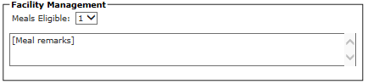

The next **Figure** is an example of the all the panels on the **Create Volunteer Screen**.

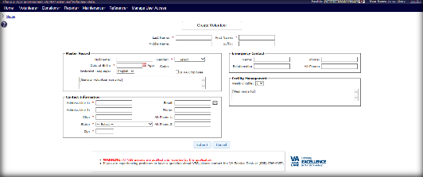

1. Once all volunteer information is defined, click **Submit**.
2. The **Edit Volunteer Screen** displays and is considered the **Volunteer Profile**.

## Edit Volunteer

The **Volunteer Profile** displays the following information specific to the volunteer:

* + - * **Name -** The Volunteer Name. Click Edit icon.to edit the name.
      * **Entry Date** – This is a *Read Only* field calculated by the system.

The system date is used when a new volunteer was created. Migrated data has static entry dates that were previously entered potentially before VSS existed.

* + - * **Years Volunteering** – This is a *Read Only* field calculated by the system as every fiscal year the volunteer has logged time at least once, in addition to every year prior to FY2002.
      * **Primary Facility** – If the volunteer has **Assignments**at more than one facility, then all the facilities with active assignments are available in the dropdown. If a volunteer has no assignments, the default value is the facility the user is currently working in.
      * **Primary Organization** – If the volunteer has more than one organization then all the active organizations display. If a volunteer has no organization assigned, the system displays this message, *“Please add at least one organization.”* A Primary Organization is established in the **Organization section** of the **Volunteer Profile**.

Within the **Edit Volunteer Screen** are multiple panels representing different functional aspects of the volunteer. The panels shown may vary depending on your screen zoom range, and may show more than one column. In this example, two columns appear at 75* screen zoom range. Enter all requiredfields on the **Edit Volunteer Screen.”** On this screen a message appears, ***“The volunteer was created successfully.”***

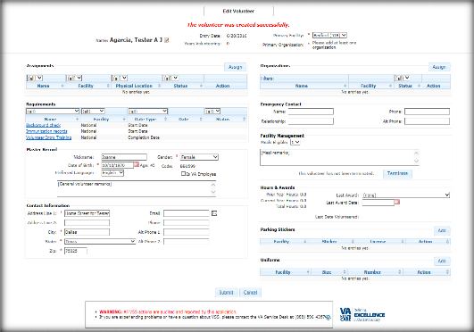

**Assignments -** This is a list of a volunteer’s Assignments across all facilities. Only active volunteer assignments are displayed in the panel by default. An empty list is indicated by the phrase, "No entries yet."

* Name *(Filterable)*
* Facility *(Filterable)*
* Physical Location *(Filterable)*
* Status *(Filterable)*
* **Assign** button

### Select Assignments

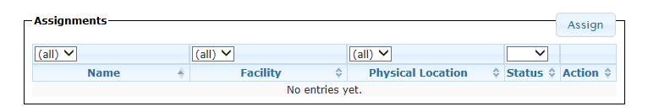

1. Click **Assign** from the **Assignments** section of the **Edit Volunteer Screen**. The **Select Assignment** box displays with all the active service-role combinations configured for the currently selected facility.
2. Click the **Facility** dropdown to add an **Assignment** from another facility to the user.
3. Once the assignment is found from the current or another facility, click the **Service Name Link** to assign.

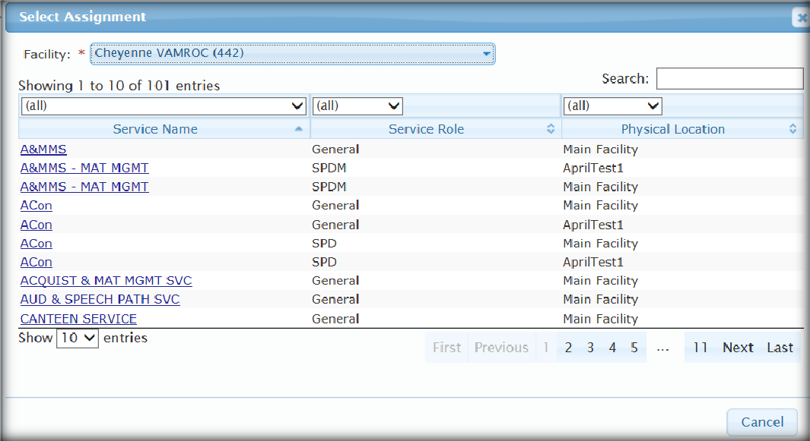

1. The new **Assignment** automatically displays in the Assignments section.
2. Users may delete an Assignment only if the volunteer has not logged time; otherwise it is set to inactive. Setting the filter to *“Inactive”* or *“All”* displays any existing inactive **Organizations** that the volunteer has currently.

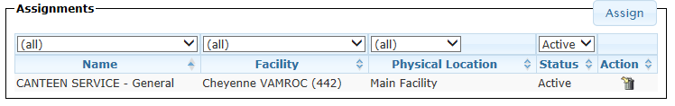

1. **Filters** default to *“All”* until a selection is made.
   * Service Name
   * Service Role
   * Physical Location
   * Status
2. **Assignments** can be reactivated by clicking the icon as long as the associated parent assignment at the facility is still active.
3. **Assignments** shown as *“Active”* are assignments volunteers can have new time posted against.
4. **Assignments** shown as *“Inactive”* cannot be assigned new time and is not shown on time posting pages (Kiosk, Regular and Occasional).

**Requirements**

Users with the **Create Volunteer** or **Edit Volunteer** access may define the fields in this panel.

* Name *(Filterable)*
* Facility *(Filterable)*
* Date Type *(Filterable)*
* Date
* Status *(Filterable)*

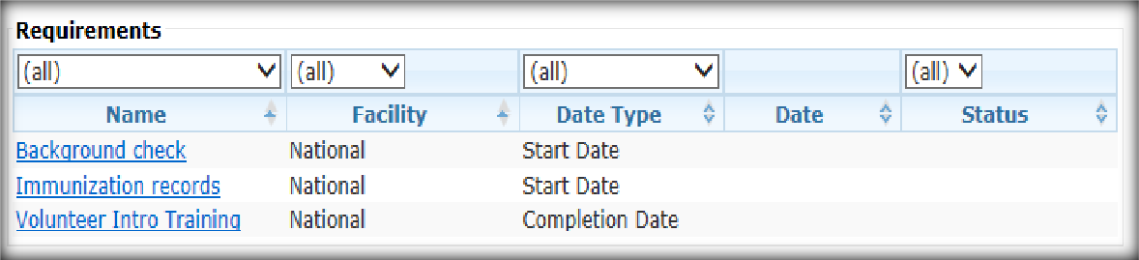

**Master Record**

Includes detailed information about the user defined when creating the new user profile.

* + - * Nickname
      * Gender (required)
      * Date of Birth (required)
      * Preferred Language
      * Code
      * VA employee check box
      * Remarks box

**Contact Information**

The **Contact Information** is the Volunteer’s demographic data updated by the user.

* + - * Address Line 1 **(**required)
      * Address Line 2
      * City (required)
      * State (required)
      * ZIP Code (required)
      * Email
      * Phone
      * Alternate Phone 1
      * Alternate Phone 2

**Organizations**

This is a list of a volunteer’s **Organizations** across all facilities. Only active volunteer assignments are displayed in the panel by default.

* + - * + Name
        + Facility
        + Status *(Filterable)*
        + Action
        + **Assign** button

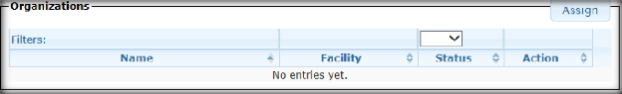

### Assign an Organization

1. Click **Assign**. The **Search for Organization** box displays.
2. Enter the **Name** (i.e., Last Name, First Name, Middle Name or Suffix) or **Abbreviation**.
3. Click **Search** or **Cancel.**

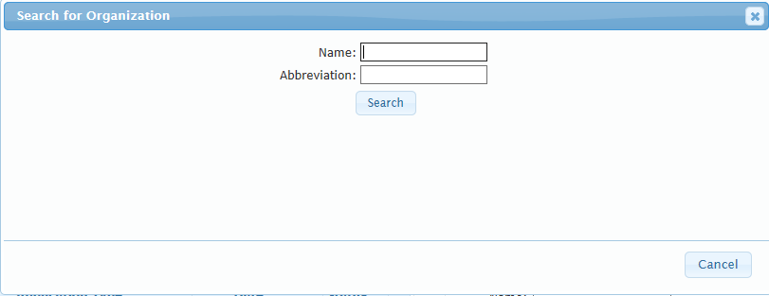

1. After clicking **Search**, the results display in the **Search for Organization** box.

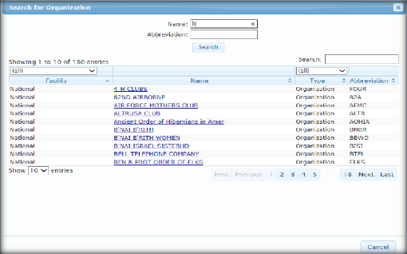

1. The Facility and Type filter defaults to **All** until a selection is made.
2. Once the organization is found, select the **Name Link** to assign the organization to the volunteer.
3. The organization information automatically populates on the **Volunteers Profile Screen**.
4. The filter can also be set to **Inactive** or **All** if the volunteer has been identified with those types.
5. Users may delete an **Organization** only if the volunteer has not logged time. Otherwise it is set to inactive. Setting the filter to **Inactive** or **All** displays any existing inactive organizations that the Volunteer has currently.

**Emergency Contact**

The **Emergency Contact** is the volunteer’s family contact information used in case of emergency.

* + - * + Name – includes First, Middle, Last Name and Name Suffix.
        + Relationship
        + Phone
        + Alternate Phone

**Facility Management**

Administrative functions such as establishing the number of meals allowed and terminating a user.

* + - * + **Meal Eligible** - Indicates the number of meals allowed and additional remarks.
        + **LEIE Exclusion Date -**
        + **LEIE False Positive** -
        + **Terminate** button – Click to expand the Termination fields.

**Terminate Date** – Select the calendar icon or enter the date to determine the termination date and enter a Termination remark (required).

**Terminate with cause** – Select the check box and enter a Termination remark (required).

Clear the Termination date if **Terminate with cause** check box is selected.The volunteer must be reactivated by a Facility Administrator or National Administrator role. Facility users and Specialists cannot reactivate Volunteers *“Terminated with Cause.”*

(New screenshot)

Hours & Awards

* + - * + **Prior Year Hours** – All logged time prior to current Fiscal Year (FY).
* **Current Year Hours** – All logged time in the current FY. The hyperlink enables if the volunteer has active time entries and in active status.
* **Total Hours** – Total hours the volunteer is credited. Includes adjusted hours.
* **Adjusted Hours** - Net of adjusted hours for this volunteer. Field is hidden if value is zero.
* **Last Award** – Last award hours the volunteer received.
* **Last Award Date** – Date of the last award hour the volunteer received.
* **Last Date Volunteered** – The date the user volunteered last.

**Figure 34: Hours & Awards**

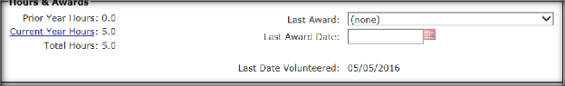

**Parking Stickers**

The volunteers may have stickers in multiple facilities, but the user can only manage the stickers for the currently logged in facility.

* Facility – Facility name and number.
* Sticker – The associated parking sticker number assigned to the volunteer.
* License – License plate number of the volunteer’s vehicle.
* Action - **Edit** or **Delete** icon.
* **Add** Button – Enables the user to add a parking sticker.

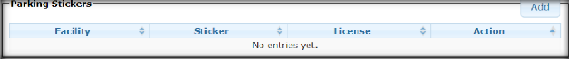

### Add Parking Sticker

1. Select **Add** to display the **Parking Sticker Details** box.
2. Define the following:

* Select the facility from the dropdown list (required).
* Sticker Number (required)
* Select the State.
* License Plate number.
* Click **Submit** or **Cancel**.

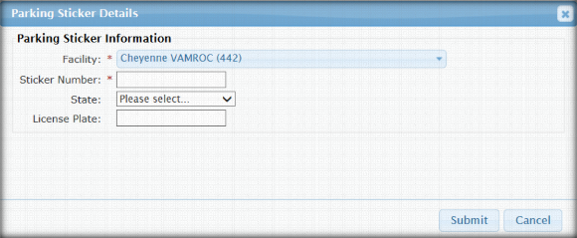

1. The Parking Sticker information automatically populates on the **Volunteers Profile Screen**.

**Locate an Existing Volunteer before adding a new one**

**Note: Test** is the *Volunteer Name* used in the ***Search*** criteria for this example.

1. The same search fields exist, define the search criteria and click **Search.**
   * Name
   * Scope (National)
   * Email
   * Identifying Code
   * Include Inactive Volunteers
   * Date of Birth
   * Search button

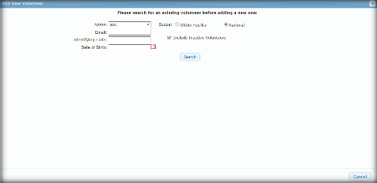

1. The next **Figure** is an example showing the **Search** results for the existing volunteer (Test/ Volunteer).

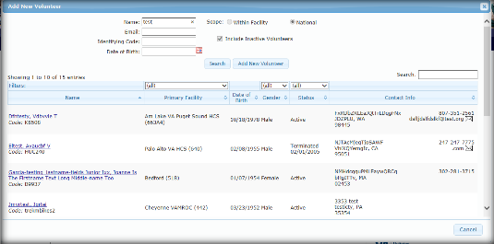

1. If no information returns from the search, a message displays, *“Sorry, no volunteers were found that matched the specified criteria.”* Refer to the next **Figure** for an example.

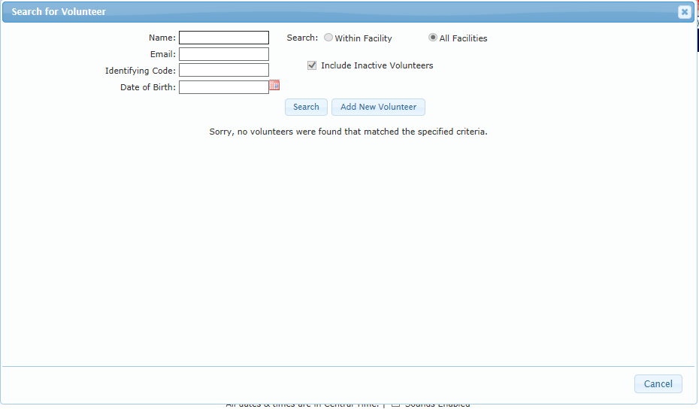

1. The next screen is **Add New Volunteer.**

**Uniforms**

The User only manages **Uniforms** that are associated to their facilities.

* Facility - Facility name and number
* Size – Indicates the size of the uniform. Sizes range from S to XXX Large.
* Number – The number of uniforms assigned to the volunteer.
* Action – **Edit** or **Delete** icon.
* **Add** button – Enables user to add a uniform.

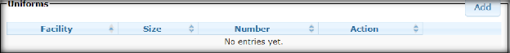

### Add Uniform

1. Select **Add** to display the **Uniform Details Screen**.
2. Define the following:
   * Select the facility from the dropdown list (required).
   * Select the size of the uniform. Options are: Small, Medium, Large, X Large, XX Large, and XXX Large.
   * Select number of uniforms needed.
   * Click **Submit** or **Cancel**.

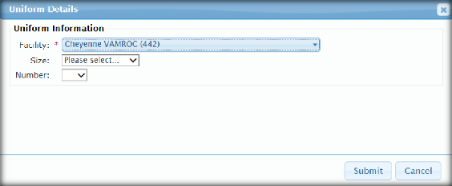

1. The Uniform information automatically populates on the **Volunteer Profile Screen**.

## Existing Volunteer Records

Existing Volunteer Profiles are available from the VSS Menu dropdown menu that enables a user to modify or view detailed information.

1. From the **Volunteers Menu**, select **Existing Volunteer Records** to display the **Search for Volunteer Screen**.

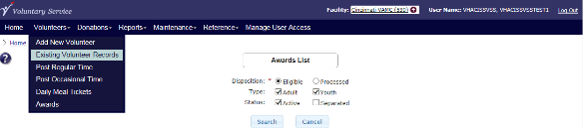

1. The user can perform a search for an Existing Volunteerin the VSS database, view the Searchresults, and select the volunteer from the results to view or edit **Volunteer Profile Screen**.

**Searchable Fields**

* + - * Name: Enter Last Name, First Name, Middle Name or Suffix
      * Scope: Facility - defaults Users current station to *Within Facility.* If the **Scope** option is checked, a dropdown list of stations of *Within Facility* displays and a *Filter* option to enter keywords.

* + - * Identifying Code (IC)
      * DOB
      * Email Address: Optional
      * Include Inactive Volunteers
      * Click **Search**
      * One piece of search criteria must be entered for the search

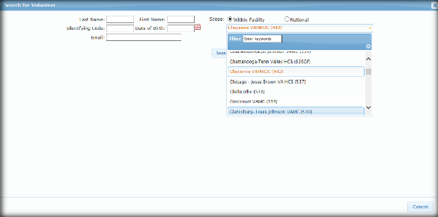

* + 1. The search results displays on the screen, including options to filter and search through the results.
    2. Click the **Volunteer Name Link** to display the **Volunteer’s Profile Screen**.

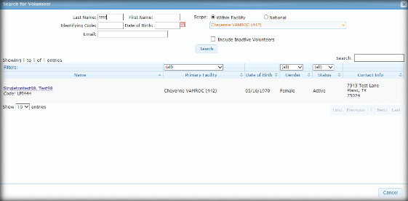

* + 1. If the ***Search*** returns no results, a display message appears, *“Sorry, no volunteers were found that matched the specific criteria”* on the screen.

## Post Regular Time

The primary use of the **Time Entry Screen** is for Facility Staff to enter and manage Volunteer time manually. This includes reviewing time entry and editing previously posted volunteer time. The screen displays in two panels, **Enter Time** and **Time Report**.

* + 1. From the **Volunteer** Menu, select **Post Regular Time** to display the **Time Entry** **Screen**.

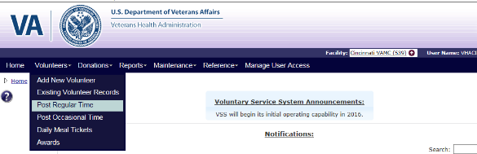

The high-level process for Posting Regular Time is:

* + 1. View a volunteer time post for a given day (default to current)
    2. Post logged time for a volunteers
    3. Post adjusted hours for a volunteer
    4. Search in current FY specific postings to edit or delete.

The **Enter Time** panel contains two radio button options- *By Date* and *By Volunteer*:

**Enter Time - By Date Option**

* + - * Volunteer – Start entering the volunteer’s name (i.e., Last Name, First Name, Middle Name or Suffix) and a dropdown list displays with potential matches. Select the volunteer’s name.
      * Hours (Decimal value that rounds to nearest .25 with a max value of 24.0)
      * Assignment (Active assignments)
      * Organization (Active organizations)
      * Action - **Delete** icon

• **+** to add rows

* + - * Press Alt + “1” anywhere to go directly to the **Post All** button.
      * **Post All** button

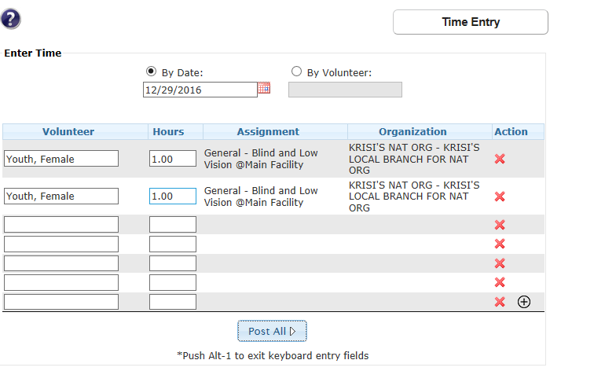

**Time Entry – By Volunteer Option**

* + - * Date – Click the **Calendar** icon or enter the date.
      * Hours (Decimal value that rounds to nearest .25 with a max value of 24.0)
      * Assignment (Active assignments)
      * Organization (Active assignments)
      * Action -  **Delete** icon

• **+** to add time entry rows

* + - * Press Alt + “1” to go directly to the **Post All** button.
      * **Post All** button

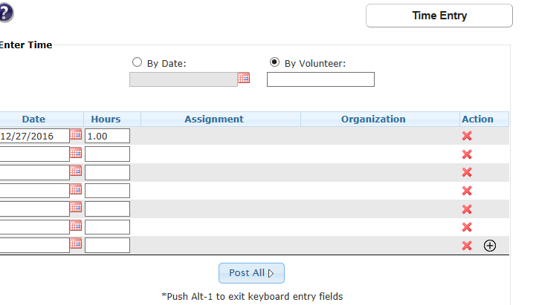

The second panel is **Time Report**.This displays time entries determined from the **Enter Time By Date** or **By Volunteer** radio buttons

**By Date -** **Time Report**

* Search field
* **Excel**, **PDF**, and **Print** enables a user to export and print a time report.
* Volunteer
* Hours
* Service Role *(Filterable)*
* Location *(Filterable)*
* Organization *(Filterable)*
* Action – **Edit** or **Delete** icon.
* The panel refreshes when a New Volunteer is selected, or when time is posted through the **Post Time** link

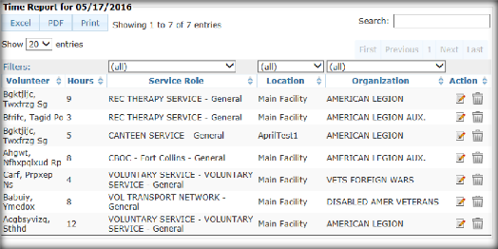

**By Volunteer - Time Report**

* Search field
* **Excel**, **PDF**, and **Print** - enables a user to export and print a time report.
* Date
* Hours
* Service Role *(Filterable)*
* Location *(Filterable)*
* Organization *(Filterable)*
* Action – **Edit** or **Delete** icon.

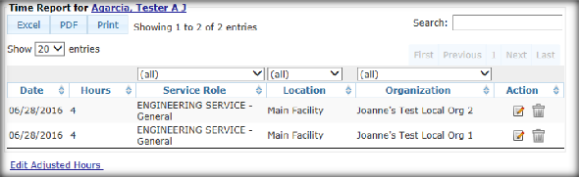

## Post Occasional Time

The **Post Occasional Time Screen** is for Facility staff to enter and manage Volunteer time manually. This includes reviewing who has logged time for the current day, and additional time interactions.

Users with the following access roles are permitted to use the **VSS Volunteers Menu** option.

* National Administrator
* Site Administrator
* Site Specialist

1. From the **Volunteers Menu**, select **Post Occasional Time** to display the **Occasional Time Entry**.

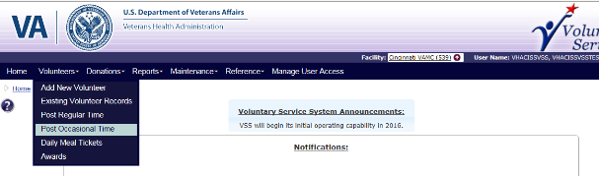

1. This screen provides the user the ability to:
   * Post Occasional Hours’ time
   * View the most recent Occasional Hours’ time postings
   * Edit existing Occasional Hours’ time postings

The initial view of the **Occasional Hours Screen** is a two part display. The first panel contains the fields for submitting a new **Occasional Hours** posting, and the second panel contains a data of all current **FY Occasional Hours** postings by most recent date, as well as Edit and Delete icons.

* **VA fiscal year begins October 1 of the prior calendar year, such that FY2016 extends from 10/1/2015 to 9/30/2016.**

**Enter Time**

* **Date** – Values must be within the current fiscal year. The system may auto resolve the year portion to make time entry quicker (There is only one valid year for any given month-day combination within a FY).
* **Number in Group** – Number of volunteers for this posting.
* **Total Group Hours** – Total number of hours the group of volunteers worked. Decimal point value but must be rounded to nearest .25 of an hour.
* **Organization** – An organization configured from a facilities organization list. Autocomplete should be enabled, only active organizations and branches are available.
* **Assignment** – Assignment and physical location. Auto-complete is enabled and only active services for the facility are available.
* **Comments** – This field is used to describe the time entry with 40 characters.
* **Action** - User can add or delete rows.
* **Post All** button

 The system does not allow duplicate entries with the same Day, Assignment, and Organization.

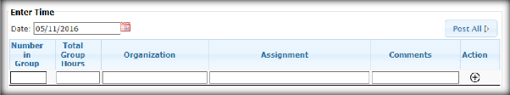

**Occasional Time**

* Search field
* **Excel**, **PDF**, and **Print** enables a user to export and print a time report.
* Date (Filterable)
* Number In Group
* Total Group Hours
* Organization (Filterable)
* Service (Filterable)
* Role (Filterable)
* Location (Filterable)
* Comments
* Action Items: **Edit** or **Delete**

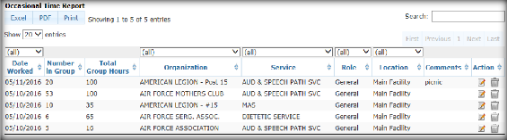

1. The next **Figure** is a depiction of the **Occasional Time Entry Screen** with all panels.

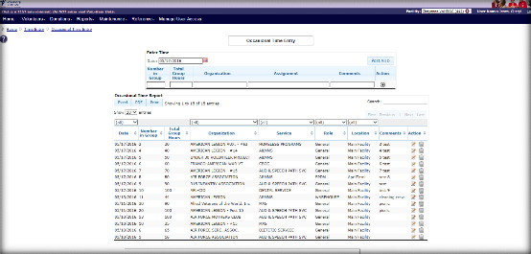

## Daily Meal Tickets

The **Daily Meal Ticket List** displays information for each volunteer who has requested a meal or who has had a meal manually added by VAVS Staff. If the site allows multiple meals, each meal requested is listed.

Users with the following access roles are permitted to use the **VSS Volunteers Menu Bar**

option.

* National Administrator
* Site Administrator
* Site Specialist

1. From the **Volunteers Menu**, select **Daily Meal Tickets** to display the **Daily Meal Tickets Screen.**

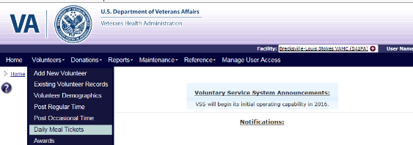

1. If the facility has indicated 1 or more meals are allowed, the **Daily Meal Tickets List** for the current date displays the volunteers who have requested a meal TODAY from the PC Kiosk, or have been manually added to this **Daily Meal Tickets List** by authorized staff.

**Data Fields and Performing Tasks of the Daily Meal Ticket**

* Volunteer Name (i.e., Last Name, First Name, Middle Name or Suffix).
* Occasional Volunteer Name - Name of the Occasional Volunteer added through the **Add** button
* **Search** button

If no entries are made for that day. “*Sorry, no meal tickets were found that matched the specified criteria.”* message displays.

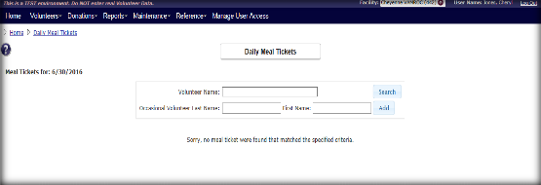

1. If the volunteer is not listed, you can search or add a meal ticket to volunteer.

### Add a Meal Ticket

1. To manually add a meal ticket on the **Daily Meal Tickets Screen**, enter the volunteer’s name (i.e., Last Name, First Name, Middle Name or Suffix) in the **Occasional Volunteer** **Last Name** text field and click **Add**. The Volunteer is added to Meal Ticket List.

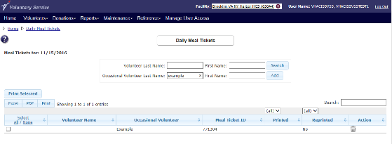

1. On the **Daily Meal Tickets Screen**, enter the **volunteer name** (i.e., Last Name, First Name, Middle Name or Suffix) and click **Search** to display the **Search for the Volunteer** box.
2. Enter the search criteria and click **Search** to display the search results. If a volunteer is located, click the **volunteer name** link.

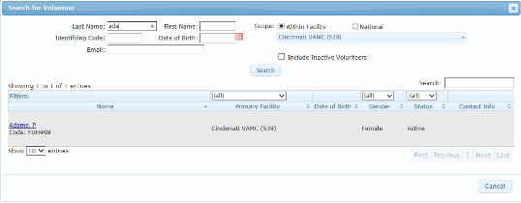

1. The volunteer added manually to receive a meal ticket displays on the **Daily Meal Tickets** list.

**Data Fields and Performing Tasks**

* + **Print Selected** button
  + **Excel**, **PDF**, and **Print** enables a user to export and print the meal ticket list.
  + Volunteer Name (i.e., Last Name, First Name, Middle Name or Suffix)
  + Occasional Volunteer Name: Name of the Occasional Volunteer added through the **Add** button.
  + Meal Ticket ID: Unique ID for the Meal ticket.
  + Printed: Date and Time the meal ticket was originally requested for print *(Filterable).*
  + Reprinted:
    - *Yes,* the meal ticket was re-requested for print.
    - *No*, the meal ticket was not requested for reprint *(Filterable).*
  + Action – Click the Delete icon to remove the meal ticket selection.

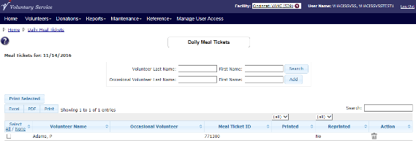

### Print Meal Ticket

The printing of the daily Meal Ticket is available from Voluntary Service and can be used as payment for each volunteer’s meal.

1. Click the **volunteer name** check box in the Meal Ticket List. Or, click the **Select All** link to select all volunteers in the list.
2. Click the **Print Selected** button.
3. The meal ticket and the Print box displays. Click **Print.**
   * + - Each Meal Ticket is for the current date only.
       - Each Meal Ticket displays the following information:
         * VAVS Logo
         * Volunteer Meal Ticket
         * Facility Name
         * Volunteer Name
         * Valid Only on this Date: [Today’s Date] in mm/dd/yyyy format
         * Meal Ticket ID
         * Maximum Value of Meal Ticket
         * Not Valid for More Than $ [Meal ticket settings. Meal ticket price]
         * Signature of Volunteer

o VA Form 10-3558

* + - * + For use by Voluntary Service Only
        + **REPRINTED** displays if a ticket has been printed more than once.
      * Each Meal Ticket is for 1 meal. If the volunteer is eligible for more than 1 meal ticket, print separately.

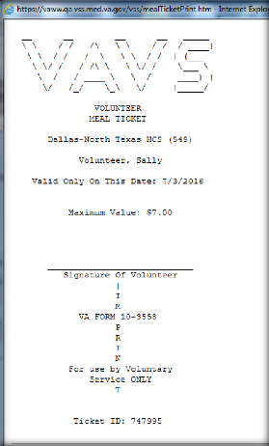

## Awards

The **Awards Lists Screen** displays a list of volunteers who have served enough hours to be eligible for an award and enables users to manage and view processed awards. The Primary Facility associated with the volunteer is responsible for managing awards.

1. From the **Volunteers Menu**, select **Awards** to display the **Awards List Screen**.

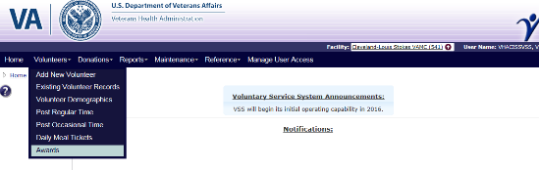

1. The user can perform a search for a volunteer eligible or received an award, view the search results, and select the volunteer from the results to view or edit **Volunteer Profile Screen**.

**Searchable Fields**

* **Disposition**
  + Eligible – Volunteer available to receive award (Default).
  + Processed – Volunteer processed for award.
* **Type**
  + Adult – Adult award.
  + Youth – Youth award.
* **Status**
  + Active – Default.
  + Separated - Inactive or Terminated or Terminated with Cause

1. Click the **Search** button to display results. The Awards List displays the following information for each volunteer:

* **Excel**, **PDF**, and **Print** - Enables a user to export and print awards report.
* **Search** – Enables a user to search for specific information in the **Awards List**.
* **Give Award** – Select the check box to grant the award to the volunteer.
* **Award Name** - Name of Award Code the volunteer is eligible for (Filterable).
* **Group Type** - Award type of the award the volunteer is eligible for (Filterable).
* **Volunteer Name** – Last Name, First Name, Middle Name and Suffix. Click the **name link** to navigate to the **Volunteer Profile Screen**.
* **Status** – Volunteer’s status (Filterable).
* **Last Award Date** - Date volunteer received last award.
* **Last Award Hours** - Award hours associated with last award.
* **Service Years** - Volunteer’s years of service.
* **Average Hours/Month** – The number of total hours of volunteer service divided by number of months of service.
* **Date Last Volunteered** – Date the volunteer last posted time.
* **Labels All/None** – Select the check box to print a mailing label for the volunteer.
* **Award Date** – Select the calendar icon or enter the date for the volunteer to receive the award.
* **Post Award** – Click the button to process the award.
* **Cancel** – Click the button to cancel the award.

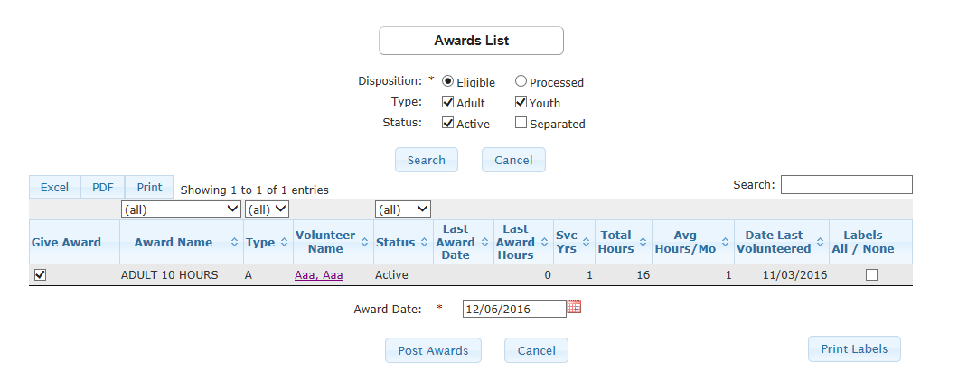

1. When the **Post Awards** button is selected, a warning message displays, “*WARNING: This process will code the awards for the selected volunteers. The process may take some time to post the awards and is an irreversible process. Do you want to continue?*”.
2. Click **OK** to process the award. The **Last Award Date** for the volunteer on the **Awards Lists Screen** will display the date the award is processed.
   * Once an award is processed, a user cannot recall the award. However, a user can post again to process volunteers previously excluded from an award or navigate to **Volunteer Profile Screen** and update each volunteer’s award manually.

# Donations

This menu is only available to local facilities. Central Office users will not see this menu. Only users with Create Donation permission may add, edit, or update Donors and Donations within a local facility. Users with Read Donation permission only have the ability to view Donors or Donations.

The following roles have **Create Donation** permission and are permitted to use the Donations Menu list:

* National Administrator (Only available if logged into a local facility)
* Site Administrator
* Site Specialist
* Site User

The following roles have **Read Donation** permission and can access the **Donations**menu with *Read Only* access to Donor and Donation information.

* + **National Specialist (*Read Only* access within a local facility**)

1. Select **Donations** from the **VSS Volunteer Menu Bar**.The following dropdown options are listed:
   * **Add New Donation**
   * **Add Anonymous Donation**
   * **Existing Donor Records**
   * **Existing Donation Records**
   * **Print Thank You Letters**

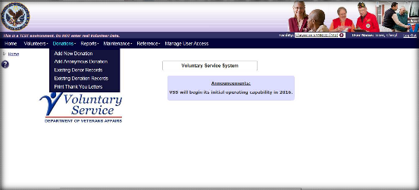

## Add New Donation

1. From the **Donations** Menu, select **Add New Donation** to display the **Search for Donor Screen**.
2. The high-level process for **Add New Donation** is the following:
   * Search existing Donor Records thoroughly in the VSS database to ensure a duplicate Donor (Individual, Individual (Volunteer), or Organization), record is not created.
   * Add New Donor Record (Individual or Organization) on the **Create Donor Screen**.
   * Edit Donations or Donor Records on the **Edit Donor Screen**.

### Search for Existing Donor - Individual

* + - 1. If searching for Donor Type as an Individual on the **Search for Donor Screen**, the user can populate any or all of the following fields to search for an Existing Donor Record.
         * Last and First Name - Last Name, First Name, Middle Name or Suffix.
         * City
         * Email
         * State
         * Phone Number
         * ZIP Code
         * Donated at: Current working Facility or Any Facility (Default)

* + - 1. If the Donor is found from the search, select the **Donor Name link** from the results list to display the **Edit Donor Screen** to edit the Donor and add a donation.

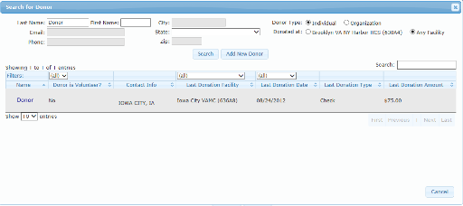

* + - 1. If no Donors are found from the search the, *“Sorry, no donors were found that matched the specified criteria.”* displays and the **Add New Donor** button is available to create a new donor profile.
      2. Click **Add New Donor** to display the **Create Donor Screen**.

### Create Donor- Individual

Define the following fields on the **Create Donor Screen**:

**Donor Type**

* + - * Individual *(*Displayed as *Read Only)*

**Link Volunteer** Button

**Donor**

* + - * Last Name (required)
      * Prefix
      * Suffix
      * First Name (required)
      * Middle Name/Initial

**Mailing Address**

* + - * Street Address 1
      * Street Address 2
      * City
      * State
      * ZIP Code
      * Email Address
      * Phone Number

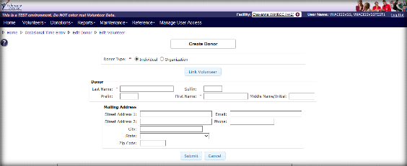

### Link Volunteer

1. If the Individual Donor is a Volunteer, click **Link Volunteer** to display the **Search for Volunteer Screen**. This allows the user to search for existing volunteers.

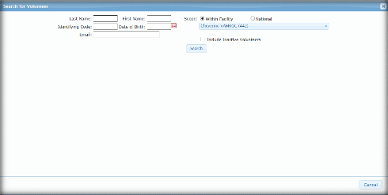

1. If the Volunteer exists as a Donor and missed in the initial Search, an error message displays, *“Volunteer is linked to another donor. Please select a different volunteer or search for the donor record established for this volunteer.”*

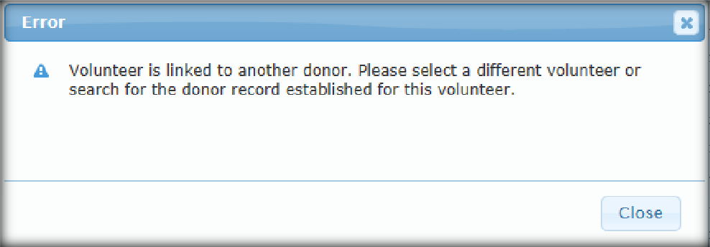

1. If the Volunteer is found, the user can select it and establish it as a Donor Record. Once the volunteer is located, the system automatically populates the volunteer’s information in the **Edit Donor Screen**.

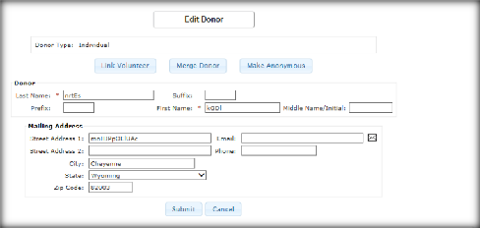

1. Once a Donor is linked to a volunteer, the user can:

* **Link Volunteer** - Allows the user to search for existing volunteers. Once a Donor is linked to a volunteer, the other options can be performed.
* **Unlink Volunteer** – The **Unlink Volunteer** button removes the linkbetween the Volunteer Profile to the Donor Profile. When the Unlink Volunteer is entered the user receives a message, *“Are you sure you want to remove the volunteer link from this donor?*”.
  + Click **OK** and the volunteer and Donor are no longer linked. The user can enter or update the Donor information or linkto another volunteer.
  + If **Cancel** is selected, the volunteer remains linked to the Donor*.*
* **Edit Volunteer** – Provides the ability to modify volunteer information on the **Edit Volunteer Screen**.
  + **Merge Donor -** Provides the ability to merge two existing donors into one from the **Edit Donor Screen**.
  + **Make Anonymous** - Provides the ability to merge two existing donors as “anonymous” into one from the **Edit Donor Screen**.
  + **Add Donation** – This button is available for users to add a donation.

### Create for Donor – Organization

* + - 1. If searching for Donor Type as an Organization on the **Search for Donor Screen**, the user can enter the **Organization Name** and then click **Search**. The system searches using the criteria to verify if the Organization has been established as a Donor.

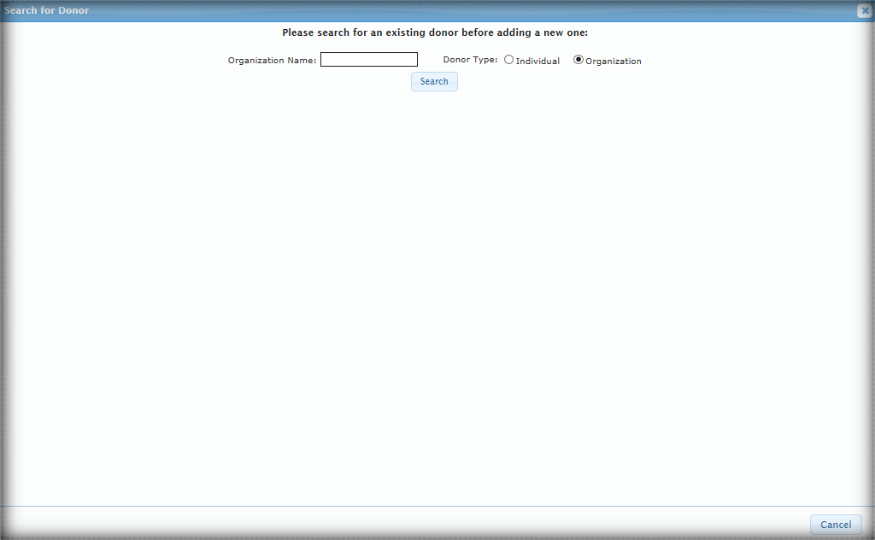

1. If no Donors are found from the search, the *“Sorry, no donors were found that matched the specified criteria.”* displays and the **Add New Donor** button is available to create a new donor.

1. If the Organization exists as a Donor and was missed in the initial Search, an error message displays, *“Organization is linked to another donor. Please select a different organization or search for the donor record established for this organization.”*

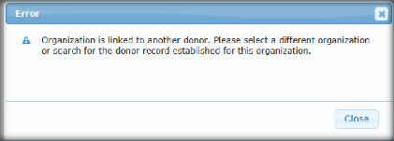

1. If the Organization is found, the user can select and establish it as a Donor Record.

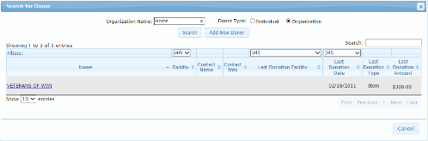

1. Once submitted, the user is returned to the **Edit Donor Screen** and the updated organization information is displayed.
2. Once the Organization is chosen as a Donor the user can establish the following on the **Edit Donor** **Screen**:
   * **Edit Organization -** This selection provides the ability to modify the organizationinformation on the **Organization Detail Screen**.

* Only Local Organizations and Local Branches within your working facility can be updated.
  + **Merge Donor** **-** Provides the ability to merge two existing donors into one from the **Edit Donor Screen**.
  + **Make Anonymous**
  + **Add Donation** – This button is available for users to add a donation from the **Edit Donor Screen.**

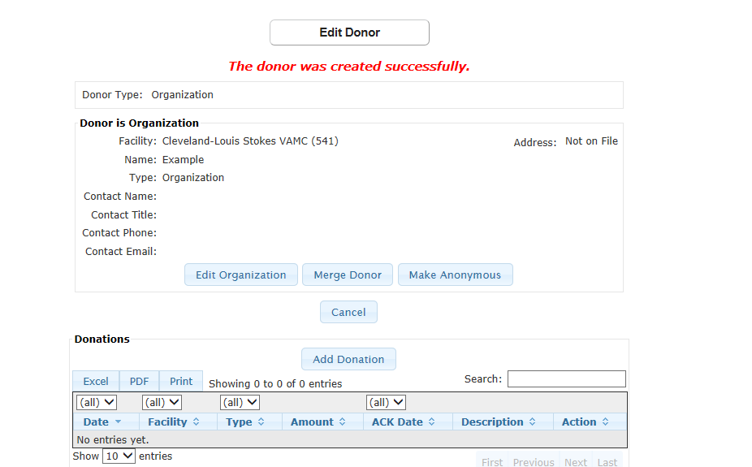

### Add Donation from Create Donation Screen

1. After establishing a new Donor or selecting **Add Donation** from the **Donations Menu**, click **Add Donations** on the **Edit Donor Screen** to display the **Create Donation Screen**.
2. The Donor section displays in a *Read Only* format regardless of Donor Type.

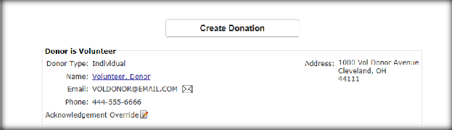

The user has the ability to override the address information for the ACK by clicking on the **Edit** icon. This override is only applicable to the selected Donation and cannot update the Donor Profile address. The user has the option to show or hide the ACK address.

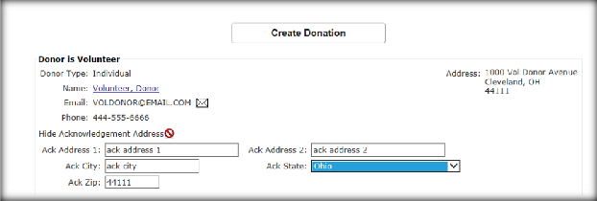

1. In the Donation panel, establishing the following:

* **Facility** - Current working facility is displayed in *Read Only* format.
* **Donation ID** - Auto-generated by the system
* **Donation Date** – Click the **Calenda**r icon or enter the date. Must be within current fiscal year (required).
* **Donation Type** – Select the donation type from the dropdown (required). Options are: Activity, Cash, Check, Credit Card, E-Donation, and Item.
  + Check Number displays when **Check** is selected (required).
  + Check Date displays when **Check** is selected (required).
  + Card Type displays when **Credit Card** is selected. Options are: American Express, Master Card, Visa, and Discover (required).
  + Confirmation Number displays when **Credit Card** is selected.
  + E-Pay Training Number displays when **E-Donation** is selected (required).
* **General Post Fund** – Select the account number defined for the working facility to apply the donation against. Defaults to noneif Donation Type is **Activity** or **Item**.
* **Donation Amount** (Required)
* **Field Service Receipt** - Receipt number from Fiscal Service once a donation has been submitted and recorded. Only displays when Donation Type is **Cash**, **Check**, or **Credit Card**.
* **ACK Date** - Automatically populated when donation document is printed, can manually be entered.
* **Reference** - Used for categorizing donations, such as division ID or sub-accounts. Dropdown list of References defined are for the working facility.
* **Letter Salutation** - The greeting used in the Thank You Letter (required).
* **Designation** - Purpose or intended recipient of the donation.
* **Affiliation** - Organization to receive credit for the donation. Only available for Individual Donors.
* **Add Affiliation -** Searches for Organizations*.* If found, clickon the **Organization Name Link** to add to the Donation Panel.
* **Delete Affiliation -** Removes the Affiliation.
* **Donation Description** - This description is used when formulating the receipt and ACK.
* **Additional Information** - Area to add information related to the donation.

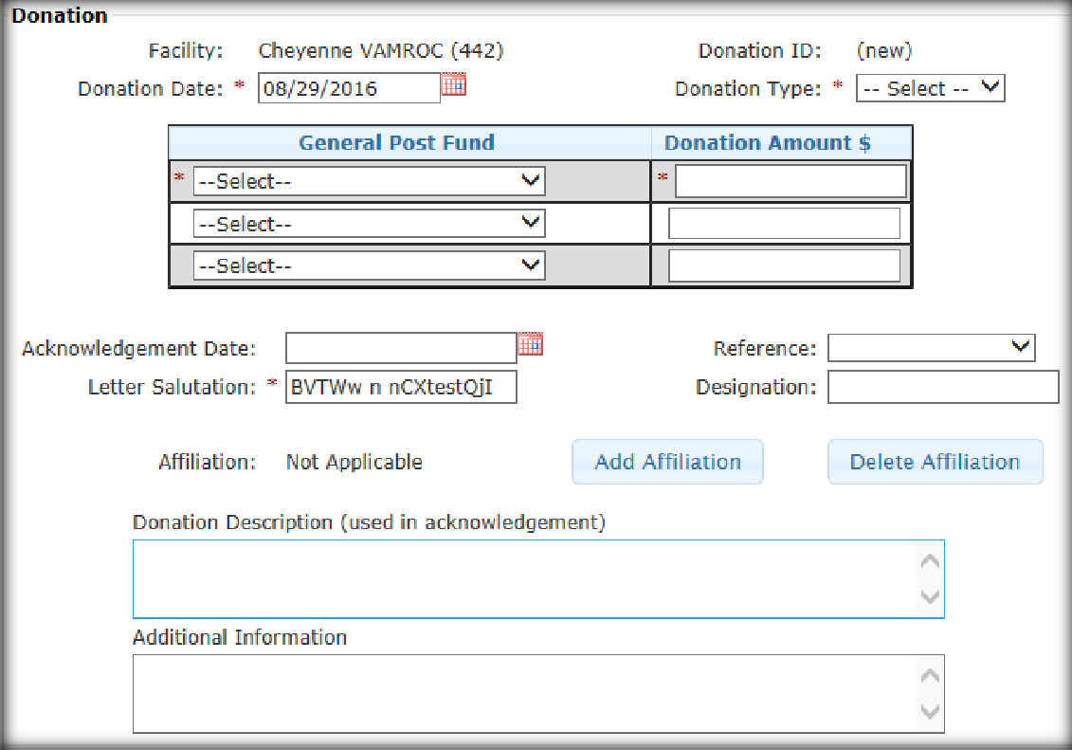

1. The fields in the **In Memory Of Panel** are available for all monetary donation types, expect for Activity or Item. Define the following:
   * + - **In Memory Of** - The field recognizes who the donation was made in honor of.
       - **Family Contact** - Family member of the individual in whose memory the donation was made.
         * This field is not required however, can only be entered if **In Memory Of** is populated. If not, user receives error message, *“In Memory Of is required when Family Contact is entered.”*
       - **Name** - Last Name, First Name and Middle Name.
       - **Street**
       - **City**
       - **State** (dropdown list)
       - **Zip** – ZIP code.

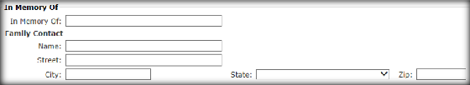

1. Define the name(s) to display in the Carbon Copy (CC) Field.
2. The **Post and Print** button allows the user to save the information on the screen and displays the **Post and Print** dialogue.

* The user can choose to print the donation receipt, memo, or Thank You Letter in PDF or Word format.
* If the Donation ACK date has not been previously populated, the date of the Thank You Letter requested is printed and displayed.
* The **Post and Print** button allows the user to save the information on the screen and display the **Post and Print** dialogue.

1. The **Post** button saves the information to the database. The user’s ID, time, and date of update is recorded.

 This information is retained in the database for auditing purposes, and is not displayed.

* The user receives a confirmation message of the saved *Donation* information.
* If edits fail, error message(s) display indicating the corrections and the action requested from the user. The data is not saved until all edits are passed.

1. If user clicks **Cancel**, updates are not saved to the database.

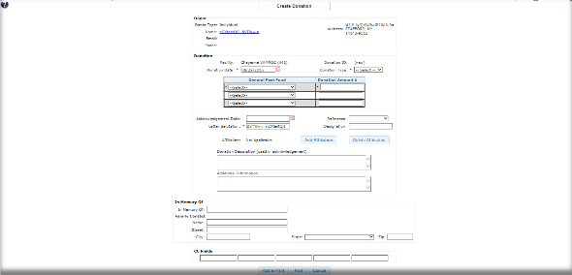

## Add Anonymous Donation Screen

1. From the **Donations** Menu, select **Add Anonymous Donation** to display the **Create Donation Screen**.

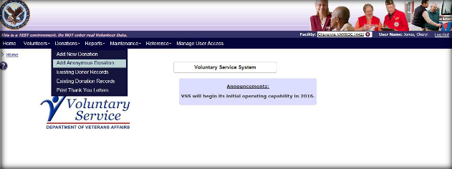

1. The Donor Type displays as Anonymous on the **Create Donation Screen**. In the Donation panel, establishing the following:

* **Facility** - current working facility is displayed in *Read Only* format.
* **Donation ID** - Auto-generated by the system
* **Donation Date** – Click the **Calenda**r icon or enter the date. Must be within current fiscal year (required).
* **Donation Type** – Select the donation type from the dropdown (required). Options are: Activity, Cash, Check, Credit Card, E-Donation, and Item.
  + Check Number displays when **Check** is selected (required).
  + Check Date displays when **Check** is selected (required).
  + Card Type displays when **Credit Card** is selected. Options are: American Express, Master Card, Visa, and Discover (required).
  + Confirmation Number displays when **Credit Card** is selected.
  + E-Pay Training Number displays when **E-Donation** is selected (required).
* **General Post Fund** – Select the account number defined for the working facility to apply the donation against. Defaults to noneif Donation Type is **Activity** or **Item**.
* **Donation Amount** (Required)
* **Field Service Receipt** - Receipt number from Fiscal Service once a donation has been submitted and recorded. Only displays when Donation Type is **Cash**, **Check**, or **Credit Card**.
* **ACK Date** - Automatically populated when donation document is printed, can manually be entered.
* **Reference** - Used for categorizing donations, such as division ID or sub-accounts. Dropdown list of References defined are for the working facility.
* **Letter Salutation** - The greeting used in the Thank You Letter (required).
* **Designation** - Purpose or intended recipient of the donation.
* Affiliation - Organization to receive credit for the donation. Only available for Donor = Individual.
* **Add Affiliation -** Searches for Organizations*.* If found, clickon the **Organization Name Link** to add to the Donation Panel.
* **Delete Affiliation -** Removes the Affiliation.
* **Donation Description** - This description is used when formulating the receipt and ACK.
* **Additional Information** - Area to add information related to the donation.

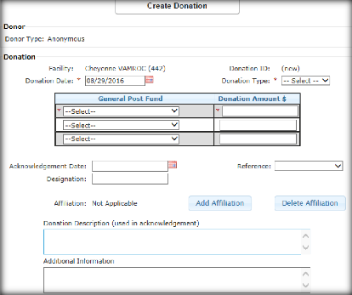

1. The fields in the **In Memory Of Panel** are available for all monetary donation types, expect for Activity or Item. Define the following:
   * + - **In Memory Of** - The field recognizes who the donation was made in honor of.
       - **Family Contact** - Family member of the individual in whose memory the donation was made.
         * This field is not required however, can only be entered if **In Memory Of** is populated. If not, user receives error message, *“In Memory Of is required when Family Contact is entered.”*
       - Name - Last Name, First Name, Middle Name or Suffix.
       - Street
       - City
       - State (dropdown list)
       - Zip – ZIP Code



1. Define the name(s) to display in the Carbon Copy (CC) Field.
2. The **Post and Print** button allows the user to save the information on the screen and display the **Post and Print** dialogue.

* The user can choose to print the donation receipt, memo, or Thank You Letter in PDF or Word format.
* If the Donation ACK date has not been previously populated, the date of the Thank You Letter was requested is printed and displayed.
* The **Post and Print** button allows the user to save the information on the screen and display the **Post and Print** dialogue.

1. The **Post** button saves the information to the database. The user’s ID, time, date of update is recorded.

 This information is retained in the database for auditing purposes, and is not displayed.

* The user receives a confirmation message of the saved *Donation* information.
* If edits fail, error message(s) display indicating the corrections and the action requested from the user. The data is not saved until all edits are passed.

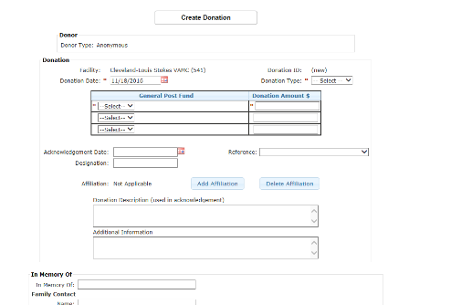

## Existing Donor Records Screen

The **Edit Donor Screen,** regardless of Donor Type, displays the Donations in the **Donations List** that allows the user to add and view existing donations.

1. From the **Donations** Menu, select **Existing Donor Records** to display the **Search for Donor Screen**.

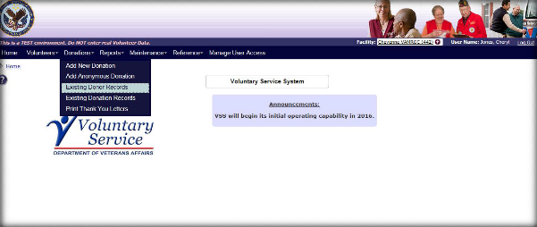

1. From the **Search for Donor Screen** screen, the user searches for an existing Donor through the **Search** options.
2. If the system identifies a match, the user is presented with the results list containing the following information:

**Search for Donor Records - Individual Results**

* **Search -** The user can conduct a **Search** within the list of results from this screen.
* **Name -** Last Name, First Name, Middle Name or Suffix.
* **Donor Is Volunteer** *(Filterable)*. The default is All.
* **Contact Information** - Address, City, State, and ZIP Code
* **Last Donation Facility** [Name (#)] *(Filterable)*
* **Last Donation Date** (*Filterable)*
* **Last Donation Type**
* **Last Donation Amount**

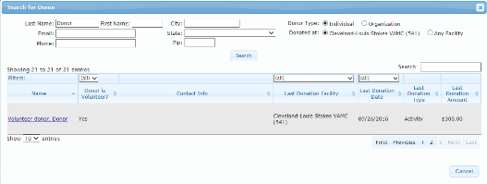

**Search for Donor Records Results - Organization**

* **Search -** The user can conduct a **Search** within the list of results from this screen.
* **Name –** Organization name.
* **Organization’s Facility** - National or Local (*Filterable)*
* **Contact Name -** Last Name, First Name, Middle Name or Suffix.
* **Contact Information** - Address, City, State, and ZIP Code.
* **Last Donation Facility** [Name (#)] *(Filterable)*
* **Last Donation Date** (*Filterable)*
* **Last Donation Type**
* **Last Donation Amount**

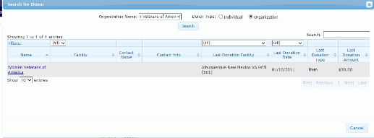

1. Once the Donor is matched, click the **Organization Name Link** to display the **Edit Donor Screen**.
2. A user can modify or view information on the **Edit Donor Screen**. The Donor, Mailing Address, and Donations Panels contain information on the Donor.

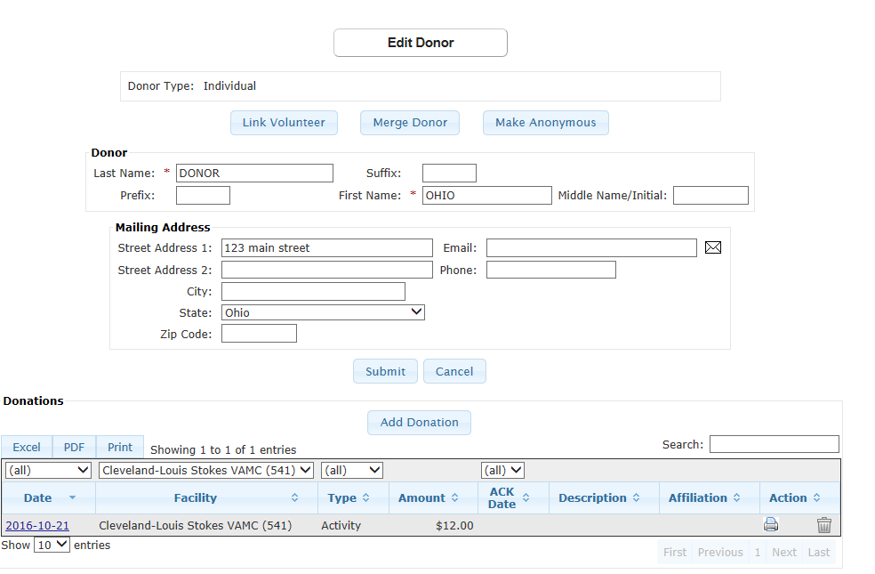

1. The **Donations List** displays donations for the working facility. The user can request to see all donations for all facilities by choosing the **Facility** filter.

* The Donations List displays the last 10 donations in donation date order from newest to oldest. The user can view additional donations by selecting the **Show entries** dropdown.
* **Add Donation** button - Donations can only be created for individuals or Active Organizations. If the Organization has a status of Inactive; the user cannot add a new donation and the **Add Donation** button is disabled.
  + **Excel**, **PDF**, and **Print –** The ability to export all the donations in the list or **Print** the list.
* **Date** - The user edits or views the details for a Donation by clicking on the **Date** hyperlink.
* **Facility** – The Facility the donation originated from.
* **Type** – Donation type. Included are: Activity, Cash, Check, Credit Card, E-Donation, and Item.
* **Amount** – Donation amount.
* **ACK Date** - Indicates the date donation was acknowledged.
* **Description** – Donation description entered for the donation.
* **Affiliation** - Affiliation is an individual donation given on behalf of an organization.
  + **Action** - The user can print/reprint a Thank You Letter, Memo, or Receipt for a donation by clicking the **Printer** icon. If the **Printer** icon is not displayed, the donation does not qualify to print/reprint a donation document.
  + If the Donation is for the working facility, an authorized user is able to delete a donation by clicking the **Trash Can** icon in the **Action Column.** A confirmation message is displayed “*Are you sure you want to delete this donation?*”
    - If **OK** is selected, the donation is deleted.
    - If **Cancel** the donation remains.
    - If the **Trash Can** icon is not displayed, the donation does not qualify or the user may not have the authority to delete the donation.

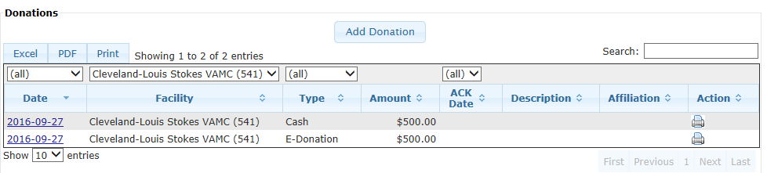

### Read Only Donations

Donations that meet the following criteria are not edited or updated. Donations are displayed in *Read Only* format:

* + All donations must be entered for the current fiscal year (Oct 1 – Sept 30) by the end of the fiscal year end (Sept 30). Users are allocated two weeks (+ 14 days grace period) after the fiscal year end to make any needed corrections for the previous fiscal year.
  + If Donation Date is in previous fiscal year (Example: date < 10/1/14) - *Read Only*.
  + If Donation Date is in this fiscal year (Example: date >= 10/1/14 and <= 09/30/15) If Current date > 10/14/15 – *Read Only*.
* If the Donation is for a facility other than the current working facility, the donation is available for display only. The user cannot update it without changing their working facility.
  + If Inactive Organization/Local Branch is Donor; the donations are *Read Only*.
  + If Inactive Organization/Local Branch is affiliated with a Donation, the donation is *Read Only*.

### Change Donor

The **Change Donor** buttons is only available when editing and updating a donation on the **Donation Details Screen**. If the user has not updated any of the Donation Detail information currently captured, the button is enabled and can be selected. This allows the user to change the Donor associated with this donation, to another Donor regardless of Donor Type by navigating to the **Donor Search Screen**.

* Once a new Donor has been selected, the updated Donor information is displayed with a confirmation message, *“Are you sure you want to move this donation to the new Donor?”*
* If confirmed, this Donation is associated with the new Donor. If not confirmed, this donation remains with the previous Donor information.
* If changes have been made to the **Donation Detail Screen** the Change Donorfeature is not available and is disabled. The user has to post the changes first before the button is enabled.

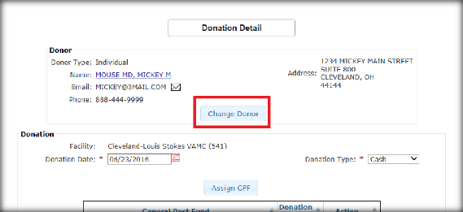

### Merge Donor or Make Anonymous

**Merge Donor** or **Make Anonymous Buttons** provide the ability to merge two existing donors into one from the **Edit Donor Screen.** Within this screen, all donations are moved from the source Donor the user is currently viewing, into the target Donor and deletes the source Donor.

* All Donations for the source Donor are moved to the target Donor regardless of the facility where it was recorded, the fiscal year of the donation and the facility the user is working in at the time the merge is executed.
* Any Donor can be merged with any other Donor. The source and target Donor does not have to have the same Donor Type.
* If the Donor Type for the source Donor = Organization, it **must** have a status of **Active** to be eligible for the merge. If the Organization is Inactive; the merge feature is not available.
* If the Donor Type for the target Donor = Organization, it **mus**t have a status of **Active** to be eligible for the merge. If the organization is Inactive; the user receives the message *“Target Donor Organization is inactive, please choose a different target Donor.”*

Only National or Site Administrators in the local facilities has access to the **Merge Donor** button.

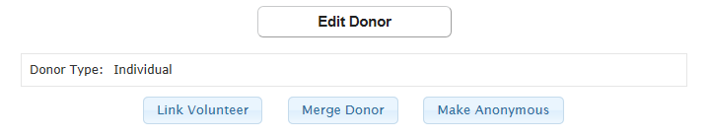

#### Merge Donor Button

If the **Merge Donor** buttonis selected, the **Search Donor Screen** displays. This allows the user to search and then select the target Donor for merging. The target Donor is the option remaining on file after the merge. Click **OK** to merge.

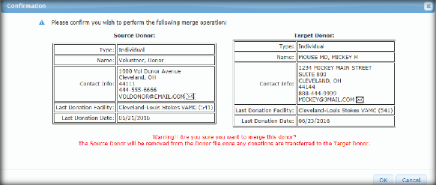

The source and target Donors cannot be the same. If they are the same Donor, the user receives a message *“The target Donor cannot be the same as the source Donor.”*

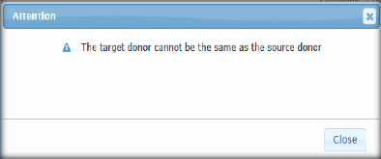

#### Make Anonymous Button

If the **Make Anonymous** buttonis selected, the **Confirmation** box displays. The target Donor Type is **Anonymous**.

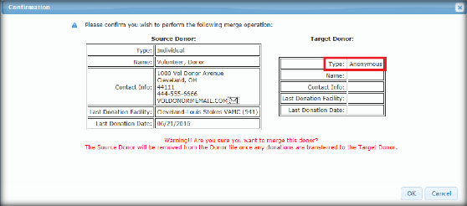

## Existing Donation Records Screen

The **Existing Donation Records** provides the ability to view a list of donations by date range. An advanced search is provided and the user can narrow the list by Donor Name, Donor Type, and ACK Date.

1. From the **Donations** Menu, select **Existing Donation Records** to display the **Donation List Screen**.

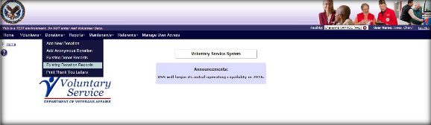

1. The following search parameters are available to allow the user to narrow the list of donations displayed:

* **Begin Date** - The Begin Date is defaulted to the current date – 30 days. The user may modify this date if desired.
* **End Date** – Select or enter the End Date to search for donations within a date range.
* **Donor Name** - Any characters to be used to narrow the list. These characters could appear in the Donor Name or the Organization or Other Organization name fields associated with the Donation.
* **Donor Type** - Lists are narrowed by Donor Types, starting with **Individual**, **Organization**, and **Anonymous**. Also, the list can be expanded to include **Organization and Individual**, **Other Groups** and **Individual or Other Groups** by clicking **Show Legacy**.
* **Acknowledgement** - Lists are narrowed to include Donations with an **Acknowledged** Date or without an **Unacknowledged** Date.
* Both acknowledged and unacknowledged donations are returned in the search results.
  + **Donation ID –** Lists are narrowed by Donation ID.
  + Click **Submit** to display Donation results.

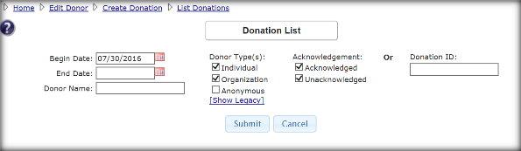

1. The following columns are available in Donation List search results:
   * **Select All/None** – Select link to print one or all donations.
   * **Date** – Date of Donation. The hyperlink navigates user to **Donation Detail Screen**.
   * **Type –** Donation Type listed. Included are: Activity, Cash, Check, Credit Card, E-Donation, and Item.
   * **Donor Type** – Donation Type listed. Included are: Individual, Organization, Organization & Individual, Other Groups and Individual, or Other Groups (Filterable).
   * **Donor Name** - Hyperlink navigates user to **Edit Donor Screen**.
   * **Affiliation** - Affiliation is an individual donation given on behalf of an organization.
   * **Organization or Other Groups** – Only displayed when Show Legacy Donor Types were searched (Filterable).
   * **Description** – Donation Description entered for the donation.
   * **Value** – Dollar amount of donation.
   * **ACK Date** – Indicates the date donation was acknowledged.
   * **Letter** - The Thank You Letter template used.
     + Monetary Donation In Memory Of
     + Monetary Donation Family Contact (letter to Donor, letter to Family Contact)
     + Monetary Donation Not in Memory Of
     + Activity Donation
     + Item Donation
   * **ID** – Donation ID
   * Each column can be sorted in ascending or descending order.
   * A Search box is available on screen to search for any value within the list.
   * In order to print Thank You Letters, the user selects one or more checkboxes in the **Select All/None** column, then clicks **Print Selected**. This button prompts the user to select which items to print (Memo, Receipt, or Thank You Letter) and offers the option of **PDF** or **Word Document** formats. After making a selection of Thank You Letter and output format, click **Submit**, and the Thank You Letter(s) opens in a separate window.
   * A request to print the Thank You Letter updates the Donation ACK Date with the current date for each donation selected.
   * If the ACK Date was previously populated, the date is not updated. The user is able to export all donations displayed in the Donation List by choosing **Excel** or **PDF** format or may choose to **Print** the list. Print Thank You Letters Screen

## Print Thank You Letters

1. From the **Donations** Menu, select **Print Thank You Letters** to display the **Donation List Screen**.

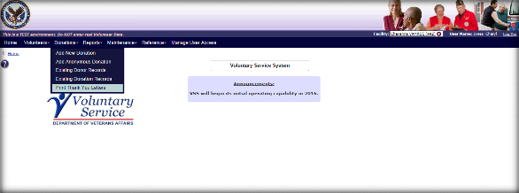

1. The **Donation List Screen** allows a user to print one or more Thank You Letters for the existing donations within the working facility and view donor and donation details.
2. From the search results, click the **Donor Name link** to view donor details.
3. Click **Excel**, **PDF**, or **Print** to view the Donation List details.
4. Enter **Begin Date** and **End Date** to search existing donations. Click **Submit**.
5. Once the results display, select the checkbox next to the donation(s) and then click **Print Selected** button.

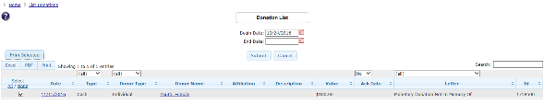

1. The **Print Donation Documents** box displays and select to print the Thank You Letter, Memo, and/or Receipt in either PDFor Word format. Click Submit.

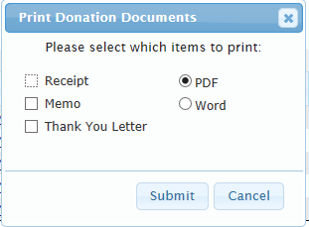

# Reports

Users with the following access roles are permitted to use the **Reports Menu**.

* **National Administrator**
* **National Specialist**
* **National User**
* **Site Administrator**
* **Site Specialist**
* **Site User**

From the **VSS Menu Bar,** select **Reports**.The following dropdown options are listed:

* **Volunteers**
* **Donations**
* **Awards**
* **Administration**

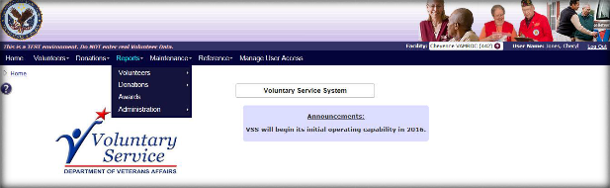

## Volunteers Reports

1. From the **Reports** Menu, select **Volunteers**. The following dropdown options are listed:

* Meal Ticket Report
* New Volunteers
* View Excluded Entities

Within each screen users can export results to print, PDF, Excel and MS Word.

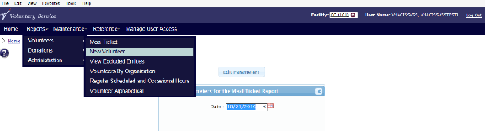

### Meal Ticket Report

The Canteen fills in the dollar amount for each meal the Volunteer has paid for using their printed Meal Ticket(s) or requests the user to sign the form instead of a meal ticket. The Canteen returns this list to the VAVS office to track the dollar amount spent on Volunteer meals.

1. From the **Reports Menu**, select **Volunteers>Meal Ticket** to display the **Specify Parameters for the Meal Ticket Report** box.

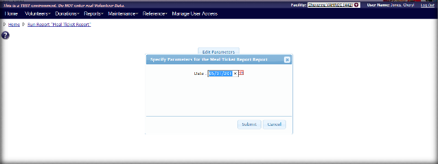

1. Select or enter the **date** to print the list. The date is defaulted to the current day.
2. Click **Submit** or **Cancel**. The next screen displays is **Meal Ticket Report**.

**Meal Ticket Report**

* Facility - Facility name and number.
* For Date - Selected Date.
* Volunteer Name - Last Name, First Name, Middle Name or Suffix.
* The report detail is sorted alphabetically by **Volunteer Last Name, First Name**.
* Meal ID
* Amount
* Signature of Volunteer
* Click **Edit Parameters** to run another Meal Ticket Report for a specific date.
* Click **Print** to print the report.
* The report run date and time is printed at the bottom of each page.
* The page number series X of Y is printed at the bottom of each page.

### New Volunteers

This report retrieves all volunteers who are new at the facility within the date range entered. For each facility selected, this report groups the Volunteers by each organization associated with their time entry. There is a count of volunteers for each organization and then a total for each facility.

This report excludes new volunteers who have not yet logged time. The same volunteer may show up for multiple organizations and independently counted in organization subtotals; however the grand total counts unique volunteers only.

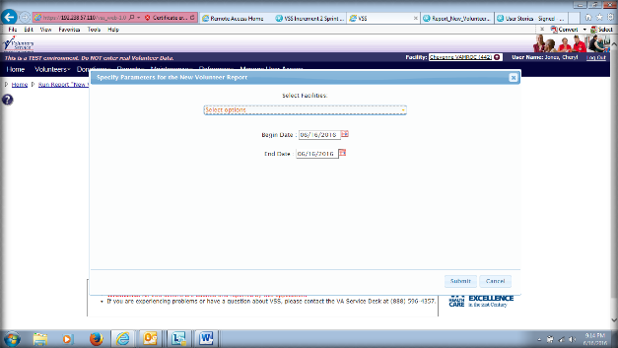

1. From the **Reports Menu** dropdown list, select **Volunteers>New Volunteer**. The **Specify Parameters for the New Volunteer Report** box displays.
2. Select one or more **Facilities** checkbox from the **Select Facilities** dropdown. Includes all donations recorded for the selected facility(s).
   1. Click **Check all** to select **all** facilities. **Uncheck all** removes the selections.
3. Select the calendar icon or enter date for the **Begin Date field** to search within the date range specified. Report includes volunteers entered on or *after* this date.
4. Select the calendar icon or enter date for the **End Date field** to search within the date range specified. Report includes volunteers entered on or *before* this date.

Click **Submit** or **Cancel**. 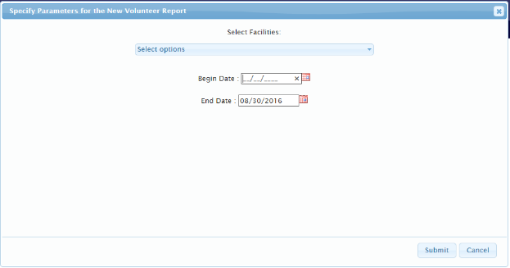

1. The next screen displays is **New Volunteers.** On this screen the users can “*Run Report of New Volunteers”* for the specified dates.

**Data Fields**

Row 1 Data:

* Facility - Facility name and number.
* Begin Date
* End Date

Row 2 Data:

* Organization Name - Displays the Primary Organization for the Volunteer.
* Volunteer Name - Last Name, First Name, Middle Name or Suffix
* Age - Volunteer’s age.
* Entry Date - Date volunteered entered.
* Assignment - Volunteer Assignment at the facility.
* Physical Location - Physical location for the assignment.
* Email - Email address.
* Phone - Contact phone.

The report is sorted alphabetically and includes:

* The Organization Total follows the Detail Report for each primary organization associated to volunteers within the facility.
* The Report Total follows the Organization Total for each facility.
* Click **Edit Parameters** to run another Meal Ticket Report for a specific date.
* Click **Print** to print the report.

### View Excluded Entities

The Office of the Inspector General publishes a List of Excluded Individuals/Entities (LEIE) of individuals and entities currently excluded from participation in Medicare, Medicaid, and all other Federal health care programs. Any individuals/entities who have been reinstated are removed from the LEIE list.

1. From the **Reports Menu** dropdown list, select **Volunteers>View Excluded Entities**. The **Excluded Entity Matches Screen** displays.

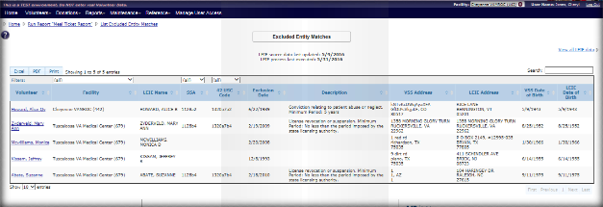

The **Excluded Entity Matches Screen** provide a list of existing Active volunteers (Active = volunteers who have their Primary Facility = to the facility the user is working in OR who have an active assignment at the facility the user is working in AND are not TERMINATED) that have an entry on the LEIE file that matches the Volunteer’s first name, last name, suffix, and date of birth.

The **All Excluded Entities Screen** provides a list of all excluded entities received in the input file (regardless of whether or not there was a match to an existing volunteer).

**Screen Information**

LEIE Source Data Last Updated: This date is when the table was last updated with new values and not when the file was last retrieved (daily). The file is updated once a month therefore VSS pulls the file daily and updates the VSS table with values.

The following fields are displayed for each match:

Data Fields

* Volunteer Name
* Facility
* LEIE Name
* SSA
* 42 USC Code
* Exclusion Date – Date this person was added to the LEIE file.
* Exclusion Description
* VSS Address composite
* LEIE Address composite
* VSS DOB
* LEIE DOB

If there are no Volunteers that match the LEIE file the user receives a message “*No Excluded Entities were found for facility (Facility name* (#))”. The link to “View all LEIE data” takes the user to “All Excluded Entities.”



## Donations Reports

This report retrieves donations made by individual and customizable Thank You Letter templates. Select **Donations Screen** from the **Reports** dropdown list. There are two options, **Manage Letter Templates** and **Grand Total of Donations**.

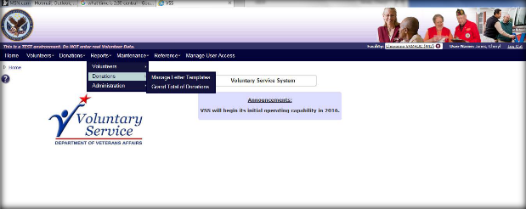

### Manage Letter Templates

All **Thank You Letter** templates initially include default text in the letter. Facilities may choose to use the default text or modify the template(s).

* + - 1. From the **Reports Menu** dropdown list, select **Donations** > **Manage Letter Templates** to display the **Manage Letter Template Screen.**
      2. The user is shown a list of the template types and has an option of templates. Each facility currently has the ability to generate 5 types of **Thank You Letters**.

This is based on the Donation Type. Letter Type 2 (Family Contact) is composed of two different letters. Therefore, there are 6 different letter templates that a user may modify:

* + - * + Type 1 - Cash/Check/Credit Card/E-Donate In Memory Of
        + Type 2 (a) - Family Contact (To Donor)
        + Type 2 (b) - Family Contact (To Family)
        + Type 3 - Cash/Check/Credit Card/E-Donate Not in Memory Of
        + Type 4 - Activity Donation
        + Type 5 - Item Donation

1. All default text for templates is based on the templates saved for CO (#101). Changes can be made to the CO template to update the default text (appropriate permissions are*required). Any changes made to the CO templates changes the default text for all sites without customized templates.
2. Upon making a selection, the user is presented with a screen to edit the selected template and click **Submit** to save changes.

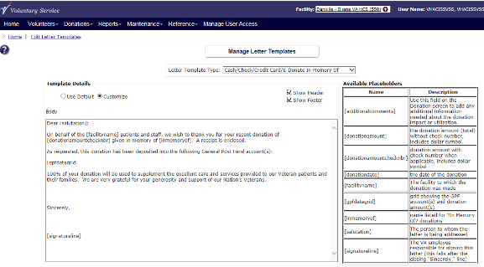

### Grand Total of Donations

This report retrieves all the donations recorded for a facility based on a date range and any additional parameters entered. There is an option to print the report in Summary form or Detail form.

* + - 1. From the **Reports Menu** dropdown list, select **Donations** > **Grand Total of Donations**.The **Specify Parameters for the Grand Total of Donations Report** box displays.
      2. Define the following:
* Type: Report format (required)
  + Summary – Allows user to generate a Summary Report.
  + Detailed – Allows user to generate a Detail report followed by a Summary Page.
* Filter Report By:
  + Facility – Allows user to select one or more facilities. Includes all donations recorded for the selected facility(s).
  + State – Allows user to select one or more states. Includes all donations recorded for all facilities whose address are in the selected state(s).
  + VISN – Allows user to select one or more VISNs. Includes all donations recorded for all stations that are in the selected VISN(s) (required).
* Date Range:
  + Begin Date: Report includes Donations with donation date greater than or equal to this date (required).
  + End Date: Report includes Donations with donation date less than or equal to this date (required).
* Show Params: Select the **Yes** or **No** Radio Button to show parameters.
* Select Facilities:
  + Select one or more **Facilities** checkbox from the **Select Facilities** dropdown
* Donor Type
  + Individual
  + Organization & Individual
  + Other Groups & Individual
  + Organization
  + Other Groups
  + Anonymous
* Donor Type - **\*Required**: Yes if Legacy Donor Type not selected
  + Activity
  + Cash
  + Check
  + Credit Card o E-Donation
  + Item
  + GPF (Only available if a single facility is selected)
  + Reference (Only available if a single facility is selected)

1. Click **Submit** to display the Grand Total of Donations report.
   * Depending on the report type, the report name displays as either Grand Total of Donation – Detail or Grand Total of Donations – Summary.

*  The report header displays at the top of each page; however, the VAVS logo only appears on the first page.

1. The following displays for either a Detail or Summary report:

**Facility Header**

* For Facility: [Facility name (#)]
* For Facilities within State: [State Name]
* For Facilities within VISN: [VISN: Name (#)]
* For Date: [Begin Date] through [End Date]
* For Donor Type: [selected Donor Types]
* For Donation Type: [selected Donation Types]
* For Donor Name: [Donor name]
* For GPF: [selected GPF]
* For Reference: [selected Reference]

**Report Type = Summary**

* Purpose: Report totals for each facility based on parameters entered.
  + The Summary report contains one page for each selected facility.
  + The Report appears in Facility Name order.
  + The Report Header displays at the top of each page
  + The Facility Header follows the Report Header.
* The Summary report displays the following information for each facility:
  + Cash: [total of all donations for Donation Type = Cash]
  + Check: [total of all donations with Donation Type = Check]
  + Credit Card: [total of all donations with Donation Type = Credit Card]
  + E-Donation: [total of all donations with Donation Type = E-Donation]
    - Total Monetary Donations: [total of all monetary donations]
  + Activity: [total of all donations for Donation Type = Activity]
  + Item: [total of all donations with Donation Type = Item]
    - Total Non-Monetary Donations: [total of all non-monetary donations]
  + Total All Donations: [total of all donations]

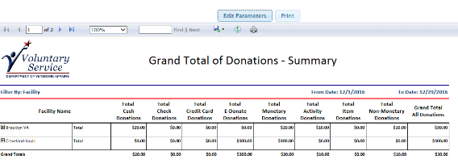

**Report Type = Detail**

* Purpose: Report 1 detail line for each donation recorded at each facility based on parameters entered. Followed by a Summary Page per Facility. Details are grouped by each Facility.
* The Detail report contains one or more pages varying by the number of donations recorded for each selected facility.
* The Report appears in Facility Name order.
* The Report Header displays at the top of each page.
* The Facility Header follows the Report Header.
* The Detail Header follows the Facility Header.
  + Each detail row in the Detail report displays the following information.
* Donor Type: [type of donor associated with donation]
  + To save space on the report; Use the Donor Type keys of :
    - A– Anonymous
    - I – Individual
    - O – Organization
    - G – Other Groups
    - OI- Organization and Individual
    - GO – Other Groups and Individual
* Donor Name: [name of donor associated with donation]
  + [If Donor Type = Individual/ Organization and Individual/ Other Group and Individual; this is the individual on the donation.]
  + [If Donor Type = Organization; this is the organization/local branch on the donation.]
  + [If Donor Type =Anonymous; it reads “Anonymous”]
* Affiliation/Organization/Other Group:
  + [If Donor Type = Individual; this is the organization affiliated with the organization if one is present.]
  + [If Donor Type = Organization and Individual; this is the organization on the donation]
  + [If Donor Type = Other Group and Individual; this is the other group on the donation]
  + Otherwise - blank
* GPF: [the GPF on the donation]
* Donation Date: [the Date on the donation]
* Donation Type: [the Type on the donation]
  + To save space on the report; use the Donation Type keys of:
    - C- Cash
    - CC – Credit Card
    - CH – Check
    - E – E-Donations
    - A – Activity
    - I - Item
* Donation Value: [the Amount on the donation]
* Reference: [the Reference on the donation]
* Description: [the Description on the donation]
  + The report is sorted alphabetically by Donor Name.
  + The Summary report follows the Detail Report for each facility.
* Report Footer
  + The report run date and time is printed at the bottom of each page.
  + The page X of X is printed at the bottom of each page.
* Report – No Data
  + If there is no data for the parameters entered, the report header displays, followed by a “*No Records Returned for this Date Range*.”
* Click **Edit Parameters** to run another report for a specific date.
* Click **Print** to print the report

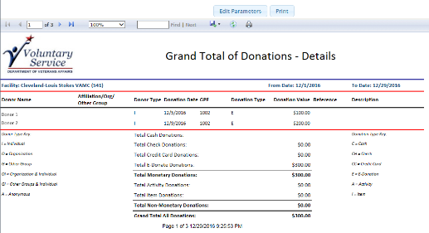

## Administration Reports

From the **Reports Menu** dropdown list, select **Administration**. The following options are three options, **Address Label Reports**, **Voluntary Service Directory** and **National Officials Listings**.

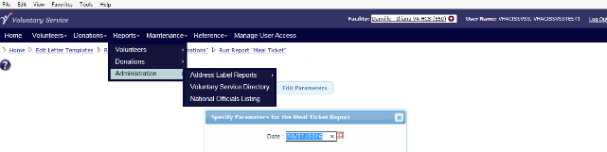

### Address Labels Report

From the **Reports Menu** dropdown list, select **Administration**> **Address Labels Report**.

A secondary menu has the following options:

* + - * **Volunteer Address Labels**
      * **Voluntary Service Directory Label**
      * **National Official Labels**

Address Label Reports are designed to support Avery 5160 compatible label sheets.

#### Volunteer Address Labels

The **Volunteer Address Label Screen** displays address labels for volunteers with specific parameters. The report is restricted to the user’s assigned Facility (s) and allows the user to print reports. Also, **Volunteer Address Labels Screen** allows the user to print address labels for mailings to volunteers associated with a selected station.

* + - 1. From the **Reports Menu** dropdown list, select **Administration** >**Address Label Reports>Volunteer Address Labels**.The **Specify Parameters for the Volunteer Address Labels Report** box displays. Define the following:

Report Parameters

**Filter by:**

* Age
* Birth Month
* Organizations
* Services
* Selected Volunteers
* All Volunteers
* All VAVS Representatives
* ZIP Code

Facility - The user is able to filter the report based on a list of Facilities.

* Filter – Enter keywords to further a search.

Age Range (Filter selected)

* Range - From a specific age to a specific age

Birth Month (Filter selected)

* Select a month from the dropdown list.

Organizations (Filter selected)

* Click the checkbox beside the organization name.
  + Click **Check all** to select **all** organizations. **Uncheck all** removes the selections.
  + Filter – Enter keywords to further a search.

Services (Filter selected)

* Click the checkbox beside the service name.
  + Click **Check all** to select **all** services. **Uncheck all** removes the selections.
  + Filter – Enter keywords to further a search.

Selected Volunteers (Filter selected)

* Click the checkbox beside the Volunteer’s name.
  + Click **Check all** to select **all** volunteers. **Uncheck all** removes the selections.
  + Filter – Enter keywords to further a search.

ZIP Code (Filter selected)

* Click the checkbox beside the ZIP Code name.
  + Click **Check all** to select **all** ZIP Codes. **Uncheck all** removes the selections.
  + Filter – Enter keywords to further a search.

Sort By

* Volunteer Name
* ZIP Code

Email Option

* Volunteer with No Email Address
* All Volunteers

Number of Labels to Skip

* A number 0 to 27 may be selected to skip printing in those label spaces. The default choice is zero. Skipped label spaces are horizontal across rows.

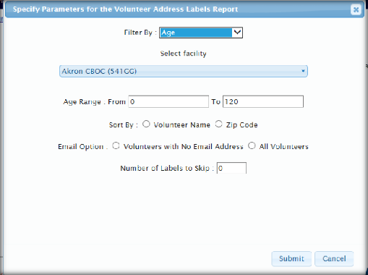

1. After entering the values, click **Submit**.Another screen opens to run the report and print.

#### Report Details

1. The report runs as of the Current Date/Time. Any data on file as of the current Date/Time is included on the report.
2. The report is formatted to Avery 5160 address labels (3 columns by 10 rows).
3. The report includes a note on the screen stating “\**Exported labels may require additional formatting.*”
4. The system displays the following detail lines on each address label.
   * Name
   * Address Line 1
   * Address Line 2
   * City
   * State
   * ZIP Code

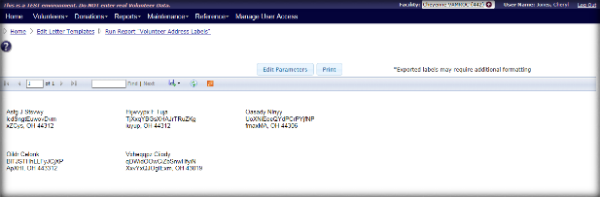

### Voluntary Service Directory Label

This report displays the **Voluntary Services Directory Label** by Facility, VISN, and State or by All Facilities. The reporting tool allows the user to print the report and the GUI includes helpful breadcrumbs at the top of each report screen.

The **Voluntary Service Directory Label Screen** allows users to print address labels for VHA stations. You can print labels for an individual station, for all stations in the country, or for all stations in a selected VISN or state.

* + - 1. From the **Reports Menu** dropdown list, select **Administration** >**Address Label Reports> Voluntary Service Directory Label**. The **Specify Parameters for the Voluntary Service Directory Label Report** box displays. Define the following:

Report Parameters

**Filter Report By**:

* **All** – report if filtered by facilities, state, and VISN.
* **Facility -** The user is able to filter the report based on a list of Facilities.
  + Filter – Enter keywords to further a search.
  + Click **Check all** to select **all** facilities. **Uncheck all** removes the selections.
* **State** – The report displays only the Stations within the selected States.
  + Filter – Enter keywords to further a search.
  + Click **Check all** to select **all** States. **Uncheck all** removes the selections.
* **VISN** - The report displays only the Stations within the selected VISNs.
  + Filter – Enter keywords to further a search.
  + Click **Check all** to select **all** VISNs. **Uncheck all** removes the selections.

Sort By

* Facility
* State

Number of Labels to Skip

* A number 0 to 27 may be selected to skip printing in those label spaces. The default choice is zero. Skipped label spaces are horizontal across rows.

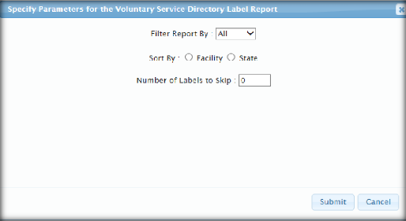

* + - 1. After entering the values, click Submit. Next, another screen opens to run the report and print.

#### Report Details

1. The report runs as of the Current Date/Time. Any data on file as of the current Date/Time is included on the report.
2. The report is formatted to Avery 5160 address labels (3 columns by 10 rows).
3. The report includes a note on the screen stating “\**Exported labels may require additional formatting.*”
4. The system displays the following detail lines on each address label.
   * Name of Facility
   * Service Title (Mail Stop)
   * Address Line 1
   * Address Line 2
   * City
   * State
   * ZIP Code

### National Official Labels

This report displays the **National Officials Labels** addresses by National Officials by Representatives (Reps), Deputies (Deps), National Certifying Officials (NCOs), Only Reps in Organizations defined as the National Acquisition Center (NAC) Executive Committee Members, and All National Officials not Reps/Deps/NCOs.

* + - 1. From the **Reports Menu** dropdown list, select **Administration** >**Address Label Reports> National Official Labels**. The **Specify Parameters for National Officials Labels Report** box displays. Define the following:

Report Parameters

* **Filters Report By:**
  + **Representatives**: The report displays only Representatives.
  + **Deputies**: The report displays only Deputies.
  + **National Certifying Officials**: The report displays only National Certifying Officials.
  + **Only Reps in Organizations defined as NAC Executive Committee Members**: This report displays Representatives defined as NAC Executive Committee Members.
  + **All National Officials not Reps/Deps/NCOs**: The report displays all National Officials that are not Reps, Deps, or NCOs.
* **Organizations**
  + The user is able to filter the report based on a list of Organizations to limit the report output to only the selected Organizations.
  + Click **Check all** to select **all** facilities. **Uncheck all** removes the selections
* **Sort By**:
  + The report output may be sorted by the Contact Name.
  + The report output may be sorted by the Organization Name.
* **Email Option** – The user can choose to filter the report:
  + All National Officials
  + Only National Officials who do not have an email address.
* **Number of Labels to Skip**
  + - * + A number 0 to 27 may be selected to skip printing in those label spaces. The default choice is zero. Skipped label spaces are horizontal across rows.

After entering the values, click **Submit**.Another screen opens to run the report and print.

# Maintenance

Users with the following access roles are permitted to use the **Maintenance Menu**.

* **National Administrator**
* **National Specialist**
* **National User**
* **Site Administrator**
* **Site Specialist**
* **Site User**

Select **Maintenance** from the **VSS Menu Bar**.The following dropdown options are listed:

* **Manage Facilities**
* **Manage Organizations**
* **Search Existing Organizations**
* **Manage Voluntary Service**
* **Manage Benefiting Service**
* **Manage Service Template**
* **Manage Volunteer Requirements**
* **Manage Staff Title**
* **Manage Award Codes**

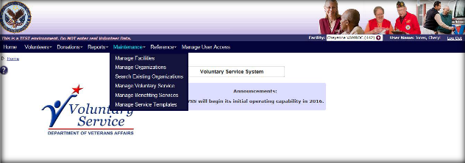

## Manage Facilities

1. From the **Maintenance Menu**, select **Manage Facilities** to display the **Manage Facilities Screen**.

 Users with Site Administrator access roles are permitted to use this menu option.

1. From the **Manage Facilities Screen**, click the **facility’s name link** to can view or edit specific details This screen permits the user to complete the following:
   * Click the **Show Inactive** checkbox to display any inactive facilities.
   * Click **Add Facility** to add a new facility to the list.
   * **Excel**, **PDF**, and **Print** enables a user to export and print a report of facilities and active nodes.
   * Enter the **facility name** or **station number** in the text box to quickly find the facility in the list.
2. The **Facility Details** section now displays. This screen permits the user to complete the following:
   * + - Manage physical locations at facilities
       - Manage facility donation parameters (e.g. GPF & donation references)
       - Manage facility meal ticket parameters
       - Manage facility Kiosk parameters

**Facility Details Data Fields**

* + - Facility Name: (required)
    - Official VA Facility: *Read Only*
    - Parent Facility: *Read Only*
    - VISN: *Read Only*
    - Address: City, State, ZIP (required)
    - Time Zone: (required) dropdown list option

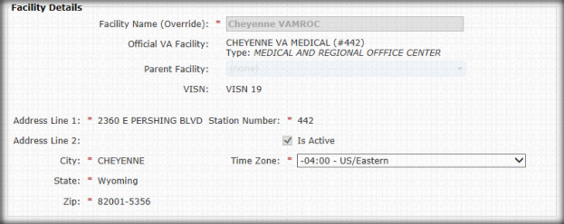

Physical locations are used within Voluntary Service as part of the assignment. These assignments represent different physical mailing addresses and are managed as part of the facility. Examples are: Cemeteries, CBOCs, or warehouses. The Main Facility is the default option at every facility.

Physical locations cannot be deleted if volunteers have logged time against an assignment. The locations must be inactivated instead. Inactivating a physical location also activates all of the associated assignments and associated volunteer assignments.

If a user wants to reactivate an assignment or volunteer assignment after reactivating a physical location, it must be done manually.

Physical Location Data Fields

* + - Location Name
    - Address
    - Contact Information
    - Volunteers: Contains the volunteers count:
      * Active - All volunteers with an active assignment for the location
      * Total - All volunteers with an assignment of any active/inactive status.
    - Click **Add Location** to add new a facility location. The **Location Details** box display with the Name, Address, City, State, ZIP Code, Contact Name, Contact Role, Contact Phone, and Contact Emails text boxes to define. Click **Submit** when finished.

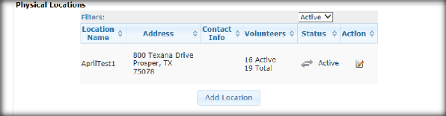

**Kiosks Data Fields**

* + - Default Language – This is the facility specific welcome text that displays to volunteers on the Kiosk login splash screen.
    - Alternate Language – This is the default Spanish language equivalent welcome text.
    - Kiosk Location – For each Kiosk at a facility an entry must be made to this table. The location is where the Kiosk is physically located at the facility. The default value is **Main** but is changed to accurately represent where the Kiosk is located. Additional Kiosks information must be entered here before local information technology can set them up for use. Expected values are descriptive locations where you place the Kiosks (e.g. Recreation Room, VSS Office, and Main Entry).
    - Printer Status – Displays if Kiosk printer is currently functioning properly. Clearly marked Kiosks are important for identifying purposes should a problem arise.
    - Queued Print Jobs – Number of queued print jobs (e.g., out of ink or paper, other issue). Normally this value is 0 or 1.
    - Last Error – This is a system error message from the Kiosk designed to assist Tier 2 and Tier 3 Support in trouble shooting, If there are Kiosk issues and this field contains a value, include it with your Helpdesk ticket.
    - Action – **Edit** Kiosk or **Delete** icon. If deleted, the Kiosk needs to be reset with a new ID; recreating it with the same name will not work.

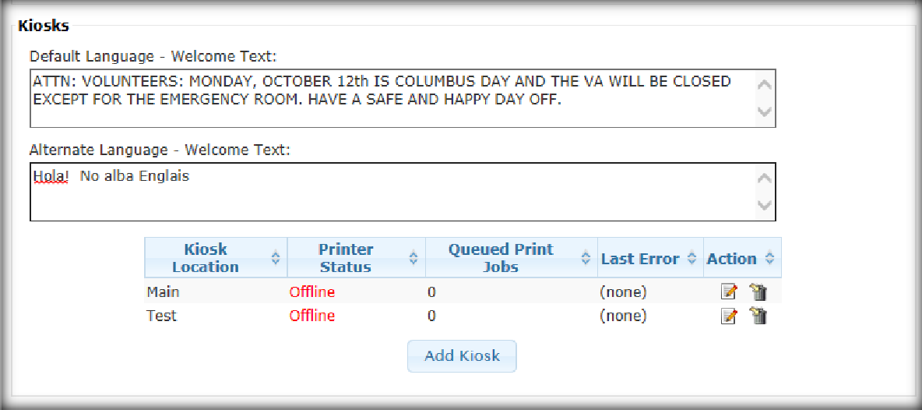

Meal Ticket Settings Data Fields

* + - Number of Meals - The number of meals offered varies between canteens. For example, the canteen opens for breakfast and lunch, but the program may only provide 1 meal a day, so the volunteer has to choose which meal. This setting should not exceed the number of meals the canteen provides daily (if your canteen only provides breakfast and lunch, it should not be set to 3).
    - Meals Allowed on Days - Select the **Saturday**, **Sunday**, or **Holidays** check boxes.
    - Meal Authorization Type - If your facility does not have active Kiosks you can set the Meal Authorization Type to **List**. This indicates that the Meal Ticket Form is delivered to the canteen manually each day. Select **Ticket** to indicate Meal Tickets are provided.
    - Meal Price - This is the maximum value of the meal tickets. The price is the same for all meals served.
    - (Required)Hours - Each subsequent meal must require more hours than the previous one.
    - (Required)Cutoff times for meals - Cutoff times are set in military time and descend chronologically for each subsequent meal.
      * Example - Volunteer with 3 meals for canteen that serves Breakfast 7am-10am, Lunch 11am-2pm and Dinner 4pm-7pm.
        + The cutoff time for 1 meal would be 1900 because the last meal is dinner, but the cutoff time for 2 meals would be 1400 because they could only eat lunch and dinner. The cutoff time for the third meal would be 1000 because the only way to eat all three meals is to arrive at the canteen for breakfast before 10:00a.m.

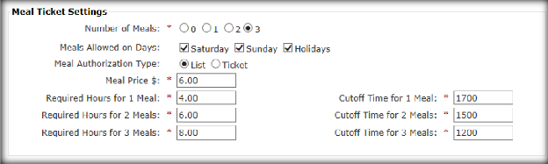

**Donation Settings and General Post Fund Data Fields**

* + - Voluntary Service Signature: The name of the program manager at the facility who signs the letters.
    - Director’s Signature: The name of the (usually non-VAVS staff) senior level staff member who signs high value donation thank you letters. This person does not have to be a director, but the term for that role in VSS is Director.
    - Set Value Amount: The donation value threshold that determines whether the thank you letter prints out with the Program Manager or Director’s signature line. Values above the threshold are printed with the Director’s name for signing.
    - General Posting Fund (GPF): Donations may be directed to these accounts. Items added to this list appear for selection on donations. A GPF can only be deleted if there are no associated donations; otherwise it may only be inactivated. Inactive GPFs do not show up for selection on new donations.
      * Click **Add GPF** to add more general posting funds.
    - Reference: References mark donations with a specific note that allow ad-hoc national reporting (Example: Hurricane Katrina, VA2K). References may be deleted if they are not used on any donations; otherwise the references may be inactivated instead. Inactive references do not show up for selection on new donations.
      * Click **Add Reference** to add more references. (optional)

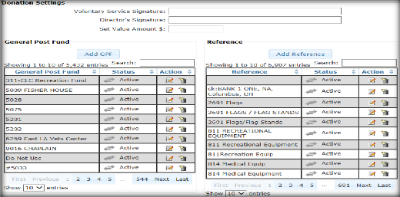

## Manage Organizations

1. From the Maintenance Menu, select **Manage Organizations** to display the **Organization List Screen**. This screendisplays and provides the ability to view a list or Search for existing organizations that are established at either the National or Local level.

 Users with National or Site Administrator access roles are permitted to use this menu option.

Organization List

From the **Organization List Screen** the user is able to view a list of all existing organizations or navigate to view the detail for an existing organization or create a new organization. The user also has the capability of exporting the list.

The **Organization List Screen** displays the Facility, Code, Name, Abbreviation, Type, NAC Committee Member flag, Annual Joint Review (AJR) month, NAC Executive Committee Flag, NAC Membership Status, and Status for each existing organization.

1. The **Organization List Screen** contents depend on the facility the user is currently working in. For example:
   * If user is working in the National facility (i.e. CO (#101):
     + The list includes organizations with a National scope.
     + The list displays in ascending order of Organization (Display) Name.
   * If user is working in another facility:
     + The list includes both the National and the Local Organizations.
     + The National Organizations are displayed first in ascending order by Organization (Display) Name followed by Local Organizations within the Facility in ascending order by Organization (Display) name.
     + The user can filter to include the organizations within the working facility or the national organizations.
2. The **Organization List Screen** only includes organizations with a status of Active initially. The user can filter to include Inactive organizations and sort the columns:

* The list can be narrowed by applying filter values for Facility, Organization Type, NAC Member, NAC Executive Member, NAC Membership Status, AJR Month, and Organization Status columns.
* If filter values have been applied, reset to All to reinitialize the list.
* The list can be exported with any filters applied and as is when exported. The export into PDF defaults to Landscape mode.
* The user can execute a Search (i.e. find any characters anywhere in any column of the list) to narrow the list to only organizations that match the Search criteria. This Search is executed against all data currently being displayed.

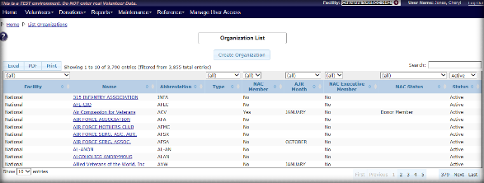

Organization Detail

After selecting **Create Organization,** the **Organization Detail Screen** displays.

1. The **Organization Detail Screen** displays the following information:
   * **Scope:** Scope reflects the option to choose the organization’s establishment at the National or Local facility (i.e. site) level (i.e. Scope). This indication is defaulted based on the user’s working facility and cannot be changed.
     + The user has the ability to change the facility if requirements are needed to enter or view a local organization.
     + The user can change organizations with Local Scope if logged into the Local facility or change organizations with National Scope logged into the National facility.
     + The Facility (Facility Name or number) that the user is currently logged into is considered the Current Facility and the associated facility that the organization is associated with when established. The user has the ability to change the facility as needed to enter a local organization for a different facility.
   * **Display Name**: The organization name and the maximum length is 35 characters (required).
   * **Full Name:** The organization’s name and is defaulted to the Display Name that can be overridden. The maximum length is 255 characters. This field may be utilized in reports generated for Mailing or when the full name is required.
   * **Abbreviation:** The shorten form of a word or name for the organization. The Organization Abbreviation is an optional field. The maximum length is 6 characters.
   * **Type:** The type of organization is provided (Required). Below is a list of the valid values:
     + Academic
     + Civic
     + Community o Corporate o Faith Based
     + Veterans Service
     + Youth
     + Other
   * **Status:** The status for the organization (required). Status values are:
     + Status value = Active: Default when creating a new organization.
     + Status value = Inactive: All fields on this screen except Status are *Read Only.* A user is not able to update any field for the Inactive status.
     + If user reactivates the organization by changing the Status to Active and clicks **Submit**, the user is presented with a message stating the organization was updated successfully. Once the status is set back to Active, fields are available for update.
   * **Contact Information**: The Name, Title, Phone, Emails, Address, City, State, and ZIP Code can be defined in the Contact Information section.
2. If Scope = Local:
   * The following fields are *Read Only* and cannot be updated by the user:
     + NAC Member
     + NAC Executive member
     + Membership Status
     + Annual Joint Review (AJR) Month
3. If Scope = National:

Central Office (CO) can designate a national organization as a member of the NAC. The status of a NAC organization can be one of the following, as determined by CO in accordance with the national organization.

* Service Member
* Associate Service Member
* Donor Member
* Associate Donor Member
* Honorary Member

NAC organizations can also be members of the NAC Executive Committee:

* + The following fields can be updated by the user:
    - NAC is required. Default is No.
    - If NAC member = Yes:
      * NAC Executive member is required. The default is No.
      * Membership Status. It is required.
      * AJR month is optional.
    - On Update, if NAC member was changed from Yes to No:
      * NAC Executive member is set to No and is *Read Only*.
      * Membership Status is set to Inactive and is *Read Only*.
  + AJR month remains and is *Read Only*.

1. When the user clicks **Submit,** edits are performed and errors are displayed. If no errors, the data is saved to the database and the user receives a message indicating *“The organization was created successfully.”* The user is able to see the organization code that was created. The user ID that performed the updates is recorded along with the current date and time.

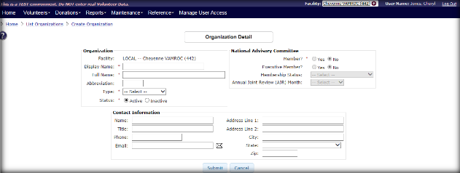

1. This information is for auditing purposes only and is not displayed. Enter all requiredfields, then click **Submit**. A message displays at the top of the screen, *“The organization was created successfully.”*
2. Local branches can also be added from this screen.
3. When user clicks **Cancel**, updates are not saved to the database. If the organization is associated with the **Current Facility**the user is working in, the user is able to update the organization. If not, the user only views the information.

**Manage National Officials**

The National Officials List option on the **Organization Detail Screen** provides the ability to:

* View any National Officials currently assigned to any National Organization and navigate to the detail information related to the assignment.
* Add a new National Official and assign to a National Organization.

 There can be no more than 1 National Official associated with each National Organization.

* Remove a National Official from a National Organization.

The **National Official List** displays the following information for each of the National Officials currently assigned to the National Organization:

* VAVS Title
* Prefix
* Last Name
* First Name
* Middle Name/Middle Initial
* National Certifying Official

The National Official is on the **National Organization Detail Screen**. There can be more than one National Official associated with each National Organization, and no new permissions are added.

**Remove National Official**

1. Select the organization associated with the official from the **Organization** dropdown list. Select the Official from the **Edit an Existing National Official** dropdown list.
2. Click the **Delete** button. The message “*Record Deleted*” displays at the top of the screen.

**Create/Update National Officials**

A user assigned to this role can create, update, edit, and view National Officials and each associated organization.

Each user serving as a National Official for a National Organization may access the **National Officials Detail Screen**.A National Organization is one that has a Scope of **National**. Once a person has been added as a National Official for a National Organization, this screen allows authorized users to view the detail and update it as needed.

The **National Officials Detail Screen** captures the following information:

**Name Section**

* Prefix
* First Name
* Middle Name/Middle Initial
* Last Name
* Organization Title
* National Certifying Official (required)
  + **Yes**
  + **No** - Default

**Contact Information**

* Street Address (required)
* City (required)
* State
* ZIP Code
* Email Address
* Telephone Number

**VAVS Committee Information**

* VAVS Title (required). Options are:
  + National Representative
  + National Deputy Representative
  + National Certifying Official
  + Honorary Representative
  + National Chairperson
  + National President
  + Not Applicable
* Appointment Date
* Expiration Date

**NAC Committee Information**

* National Executive Committee Member(required). Options are:
  + Yes
  + No – Default
* Appointment Date
* Expiration Date

Click **Submit** and the following occurs:

* Data is saved to the database.
* If any errors, the data is not saved to the database. The user receives a message to identify what changes are needed. The User ID updates the date and time of the user making the updates is recorded.
* If user clicks **Cancel**, updates are not saved to the database.

**Manage Local Branch**

The **Local Branch List** option on the **Organization Detail Screen** provides the ability to:

* View any Local Branch (s) currently assigned to any organization and navigates to the detail information for the Local Branch.
* Add a new Local Branch to the Organization.
* Edit or Inactivate a Local Branch for the Organization.

The **Local Branch List** displays the following information for each of the Local Branches established for the Organization:

* Facility Name (#) – Select **All** to view all facilities or select an individual facilities.
* Local Branch – Select to view a specific Local Branch.
* Contact Name
* Title
* Address - City, State, and ZIP Code
* Email
* Status - Active or Inactive. Defaults to Active. User can change to see Inactive and/or All.
* If the Organization is Active, the user can create a new or edit an existing Local Branch for the organization.
* If the user is assigned **Read Organization** the user can view the details for a Local Branch.
* Each column in the list can be sorted in ascending or descending order.
* Facility, Branch and Status columns can be filtered.
* The user can execute search (i.e. find any characters anywhere in any column of the list) to narrow the list to only Local Branches that match the search criteria entered. This search is executed against all data currently being displayed.

### Create/Update Local Branch

**Create**

If the Local Branch for the organization is associated with the current facility the user is working in, the user can update the Local Branch. Local Branches are established for each facility. The user must be working in a Local facility in order to add a Local branch. The user cannot be working in the National facility (CO #101) and add a Local branch. If not, the user is only able to view the information.

**Update**

If the Local Branch for the organization is associated with the current facility the user is working in, the user can update the Local Branch. If not, the user is only able to view the information.

## Search Existing Organizations

* + 1. From the **Maintenance Menu**, select **Search Existing Organizations** to display the Search for Organization box.

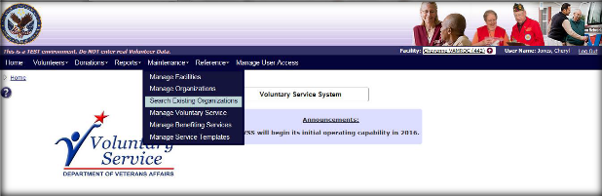

* + 1. Enter Search criteria:
       - Name
       - Abbreviation
       - Information on the National or Local Organization displays depending on your facility.
       - Optional to Include Inactive Organizations
    2. The next screen to appear is the **Search for Organization.**
    3. If an Organization is located, the user can select the name link and the Organization Detail Screen displays.

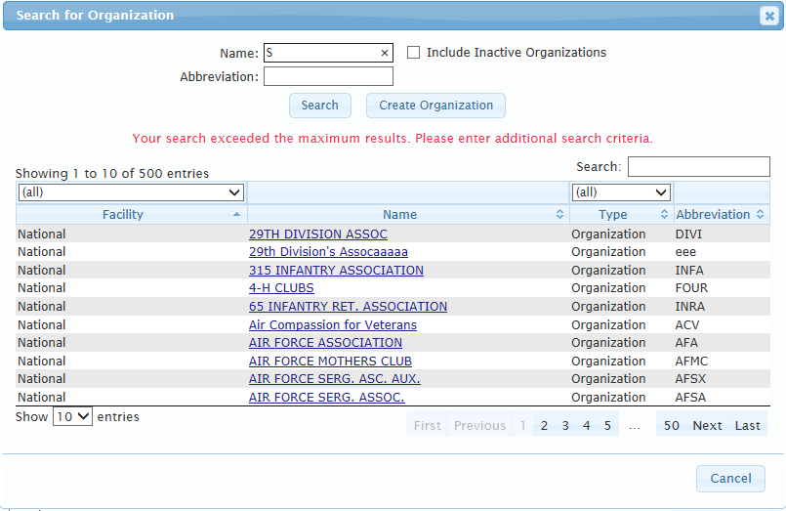

## Manage Voluntary Service

* + 1. From the Maintenance Menu, select **Manage Voluntary Service** to display the **Voluntary Service Detail Screen**.
* **Users with National or Site Administrator access roles are permitted to use this menu option.**

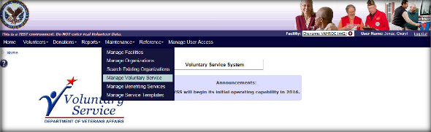

* + 1. The **Voluntary Service Detail Screen** displays the following:

Service and Contact Information Panel

* Service Title (required)
* Primary Phone (required)
* Fax Number
* Service Type (required)
* Alternate Phone
* Mail Stop (required)

**Program Manager’s Immediate Supervisor**

* Name
* Title
* Click **Search** to display the Search for User box. Then enter search criteria to locate a Program Manager.



**VAVS Information**

* VAVS Committee Established
* VAVS Information Last Reviewed (read only)
* Update VAVS Last Reviewed Date
* Costs – Operating Costs and Staff Costs
* Click **Submit** or **Cancel** to update section.

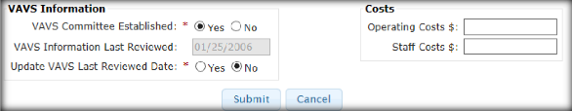

### Create and Manage Voluntary Service Staff

The **Voluntary Service Detail Screen** provides the ability to assign a staff member, view applicable details for the Voluntary Service Staff, or navigate to the Staff Member record. Also, the user can view or edit the full details related to the staff currently associated with the Voluntary Service office at the facility.

* + 1. From the **Maintenance Menu**, select **Manage Voluntary Service** to display the **Voluntary Service Detail Screen**.
    2. In the VAVS Staff Members panel, click **Add Staff**. The **Search for User** **Screen**.

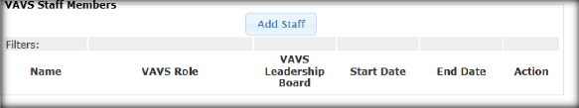

* + 1. Enter the search criteria and select the name link to display **Voluntary Service Staff Screen**.

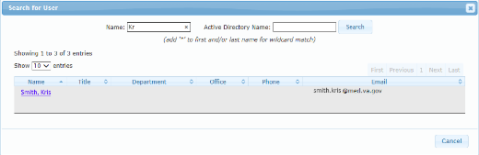

* + 1. The Voluntary Service Staff Screen provides the ability to:
       - Associate a VA staff member serving as Voluntary Service (VAVS) Program Manager or support for the VAVS office.
       - For example, remove the association for the VA staff member serving as VAVS Program Manager or support for the VAVS office.
       - Edit details related to the VA staff assignment at the VAVS office.
       - View details related to the VA staff assignment at the VAVS office.

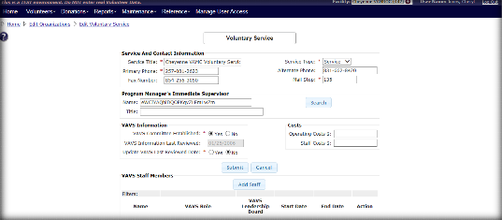

## Manage Benefiting Service

 Users with Site Administrator access roles are permitted to use this menu option.

* + 1. From the **Maintenance Menu**, select **Manage Benefiting Service** to display the **Manage Benefiting Service & Roles Screen**.

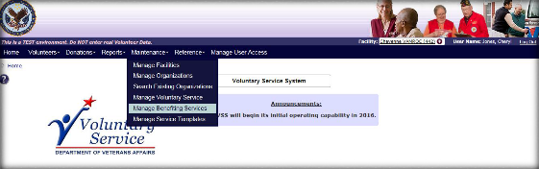

* + 1. The **Manage Benefiting Service & Roles Screen** displays the following:
       - Click **Add Service** to add another service.
       - Select the **Facility** dropdown to view service information at another facility.
       - Search text field available.
       - Filter by **Local** or **National Scope**, **Game Service**, and **Status**.
       - In the **Action** column, perform the following:
         * Select the **Edit** icon to modify the Benefiting Service.
         * Select the **Add** icon to create an additional National Benefiting Services and Roles.
         * Select the **Delete** icon to delete the Benefiting Service.

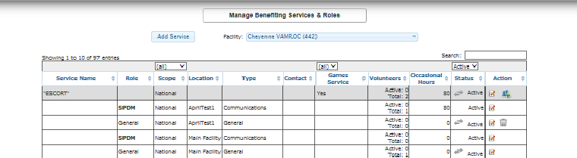

* + 1. If the user selects **Add Service**, the **Add National Benefiting Services and Roles Screen** displays. The following functions and fields are available:
* Physical Locations (Filterable)
* Search capabilities
* Select a Service & Role
* Games (Filterable)
* Abbreviation
* Add Local Service
* Submit or Cancel

* + 1. When the user selects **Add Local Service**,the **New Benefiting Service box** displays:

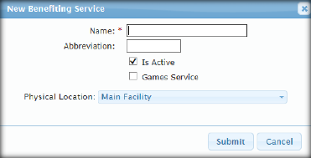

## Manage Service Templates

* + 1. From the **Maintenance Menu**, select **Manage Service Templates** to display the **Manage Service Templates Screen**.

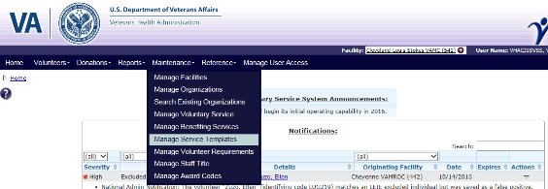

* + 1. The **Manage Templates for Benefiting Service & Roles Screen** displays the following:
       - Click **New Service Template** to add another template.
       - Search text field available.
       - Filter by, **Game Service**, and **Status**.
       - In the **Action** column, perform the following:
         * Select the **Edit** icon to modify the Benefiting Service Template.
         * Select the **Add** icon to create an additional Benefiting Service Role Template.
         * Select the **Delete** icon to delete the Benefiting Service Template.

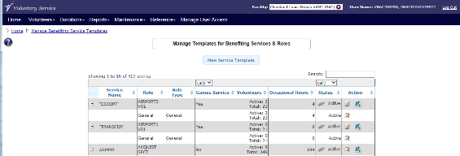

* + 1. If the user selects **New Service Template**, the **New Benefiting Service Template** box displays. The following functions and fields are available:
* Name (required)
* Abbreviation
* Game Service
* **Submit** or **Cancel**

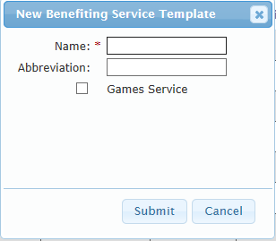

## Manage Volunteer Requirements

The National Administrator has the ability to define specific requirements for volunteers in the system. These requirements apply to all volunteers at a facility or for a facility administrator. The requirements also apply to all volunteers in all facilities for a national administrator.

Users with National Administrator access roles are permitted to use this menu option.

* + 1. From the **Maintenance Menu**, select **Manage Volunteer Requirements** to displaythe **Manage Requirements Screen**.
    2. The default view of the **Manage Requirements Screen** is a data grid that displays all requirements depending on your role:

### Both Administrative Roles

* Active requirements are shown by default (status filter = active)
* Name, Description, Application Type, Date Type, Status and Action (Active/Inactive)
  + - * + Select the **Edit** icon to modify the Requirement.
        + Select the **Add** icon to create an additional Requirement.
        + Select the **Delete** icon to delete the Requirement.
* The ability to add a new requirement.

Facility Administrator vs National Administrator

* The radio button is only visible to National Administrators and is set to **National** by default.
* National Administrators do not see the logged in facility requirements without changing the radio button to **Facility**. If the radio button is set to facility requirements, the user has access for all functionality (except they see the option to go back to National requirements panels).

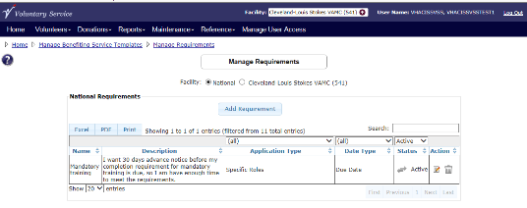

* + 1. The **Add Requirement** button is located on the top right of the data grid. When clicked, **Add New Requirement** box displays.

**Requirement Basic Fields**

* Name - 50 characters (required)
* Description - 250 characters (required)
* TMS Course ID
* Active – Select the **Yes** or **No** radio button.
* Date Type –Initial values are:
  + Completion Date
  + Due Date
  + End Date
  + Expiration Date
  + Not Applicable
  + Start Date
* Notification Period
  + Not Applicable
  + 30 Days
  + 60 Days
  + 90 Days
* Valid Statuses – Select the following check boxes:
  + New (automatically selected)
  + Not Applicable
  + Blocked
  + Not Met
  + In Progress
  + Met (automatically selected)
* Prevent Kiosk Time Posting if Not Met: Select the **Yes** or **No** radio button.

**Requirement Application Fields**

Apply this requirement to - Select one of the requirements:

* All Volunteers
* Role Type
  + Administrative/Clerical
  + Advisory Committee
  + Clinical/Patient Care
  + Communications
  + Driver
  + Escort
  + Faith-Based/Religious
  + Food & Nutrition
  + General
  + Information Technology
  + Special Events
* Specific Role Template – When selected, the Template List is displayed and a user can select the service name.
* Click **Submit** or **Cancel**.

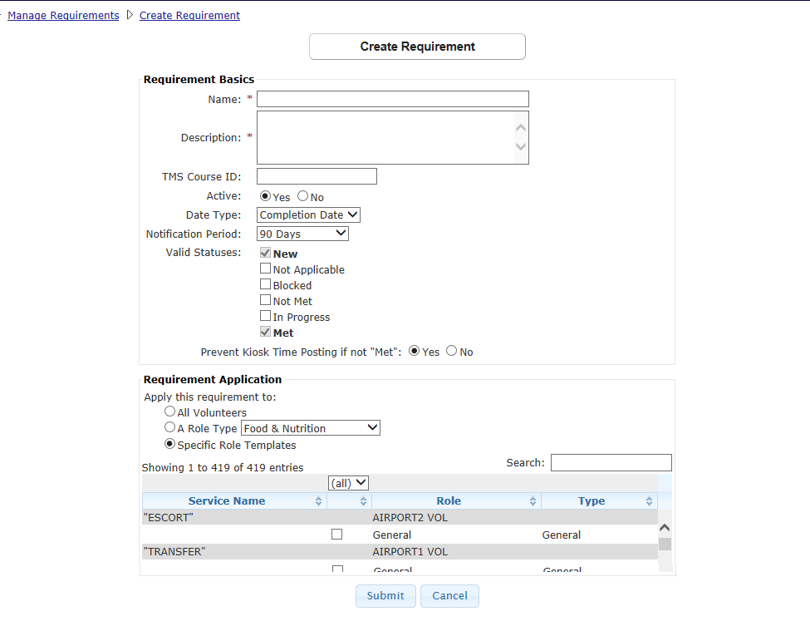

## Manage Staff Titles

* + 1. From the **Maintenance Menu**, select **Manage Staff Titles** to displaythe **Manage Requirements Screen**.

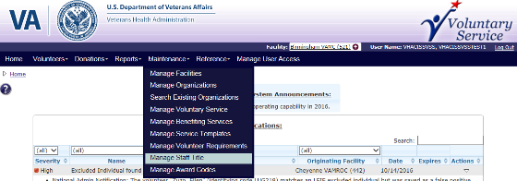

* + 1. The **Manage Staff Title** **Screen** displays the following:
       - Click **Add Staff Title** to add a new staff title.
       - **Excel**, **PDF**, and **Print** enables a user to export and print report staff titles and statuses.
       - Search text field available.
       - **Name** – Click the **name link** to edit the staff title options.
       - **Descriptio**n – Description of the staff title.
       - **Is Chief** - Indicates if the staff title represents a chief role (Filterable).
       - **Is Chief Supervisor** – Indicates if the staff title represents a chief supervisor role (Filterable).
       - **Status** – **Active** initially displays. The user can filter to include **Inactive** staff titles (Filterable).
       - In the **Action** column, select the **Delete** icon to delete the staff.

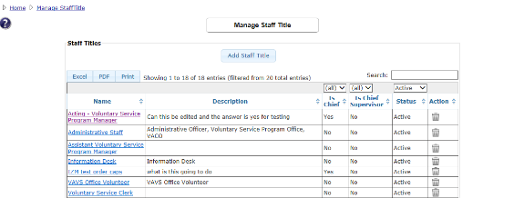

* + 1. If the user selects **Add Staff Title**, the **New Staff Title** box displays. The following functions and fields are available:
       - Name (required)
       - Description
       - Is Chief
       - Is Chief Supervisor
       - Is Active
       - Click **Submit** or **Cancel**.

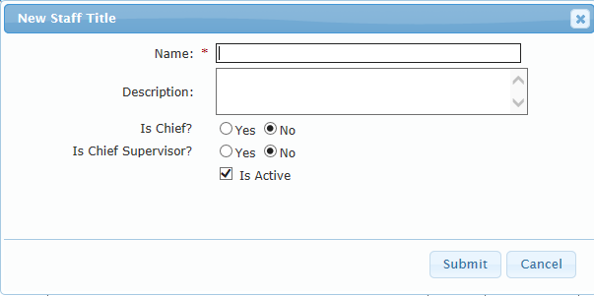

## Manage Award Codes

Users can create and manage volunteer service awards in VSS as a way to reward volunteers for their time. From the **Manage Reward Codes Screen**, the user can view a list of all existing award codes or navigate to view details for an existing award code or create a new award code. They also have the capability to export the list.

* + 1. From the **Maintenance Menu**, select **Manage Award Codes** to displaythe **Manage Award Codes Screen**.

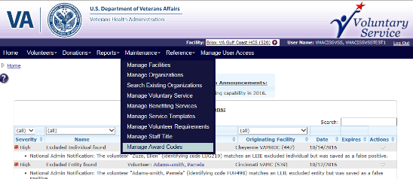

* + 1. The **Manage Award Codes** **Screen** displays the following:
       - **Add Award Code** button
       - **Excel**, **PDF**, and **Print** enables a user to export and print award codes and statuses.
       - **Search** text field available.
       - **Name** – Click the **name link** to edit the award code options.
       - **Code** – Code for the award.
       - **Required Hours** – The hours required to be eligible for the award.
       - **Award Hours** - The completed hours of service to be eligible for the award.
       - **Award Group Type** – Volunteer age group eligible for the award (Filterable).
       - **Status** – Only Award Codes with the status of **Active** are initially available. The user can filter to include **Inactive** award codes.
       - In the **Action** column, select the **Delete** icon to delete the Staff.

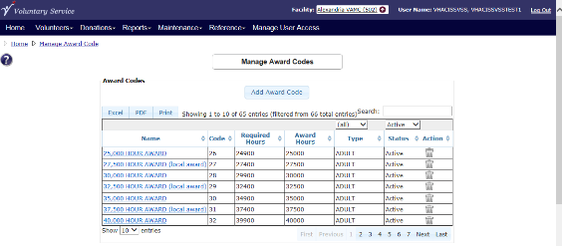

* + 1. Click **Add Award Code** to display the **Add New Award Code** box. Define the following:
* Code
* Name
* Required Hours
* Award Hours
* Award Group Type – Adult, Youth, and Other.
* **Is Active** checkbox
* Click **Submit** or **Cancel.**

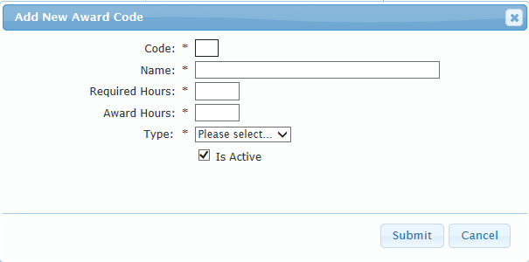

# Reference

The **Reference Menu** provides an easy access to important links, policies, procedures and other publications directly from VSS Web.

From the **Reference** **Menu**, thefollowing options are available:

* 1. Policies
  2. VAVS SharePoint
  3. VAVS Website

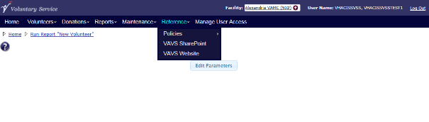

## Policies

For additional information on policies, refer to the links below: [VHA Directive 1620](http://www.va.gov/vhapublications/ViewPublication.asp?pub_ID=3035)

[VHA Handbook 1620.01](http://www.va.gov/vhapublications/ViewPublication.asp?pub_ID=2165)

[VHA Handbook 1620.02](http://www.va.gov/vhapublications/ViewPublication.asp?pub_ID=3042)  [VHA Handbook 1620.03](http://www.va.gov/vhapublications/ViewPublication.asp?pub_ID=2840)  [VHA Directive 2008-020](http://www.va.gov/vhapublications/ViewPublication.asp?pub_ID=1675)  [VHA Directive 4721](http://www.va.gov/vhapublications/ViewPublication.asp?pub_ID=1571)  [VHA Handbook 4721](http://www.va.gov/vhapublications/ViewPublication.asp?pub_ID=1570)

## VAVS SharePoint

For information on the VAVS SharePoint, refer to the link below: <http://vaww.teamshare.va.gov/vavs/default.aspx>

## VAVS Website

For information on the VAVS Website, refer to the link below: <http://www.volunteer.va.gov/>

# Manage User Access

Users with the following access roles are permitted to use this menu option.

* **National Administrator**
* **National Specialist**
* **National User**
* **Site Administrator**
* **Site Specialist**
* **Site User**

From the **VSS Menu**, select **Manage User Access** to display the **Manage User Access to VSS Screen**.

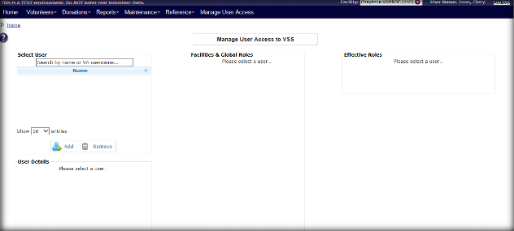

## Manage User Access

The **Manage User Access to VSS Screen** can only be accessed by the National or Site Administrator. The administrator uses this screen to assign roles to site users. The role determines what data the user can access. The term **User** refers to Voluntary staff members, not volunteers. Volunteers are administered through the **Add Volunteers** and **Edit Volunteers** screens.

### Select User

1. In the **Select User** text field, search by name or VA username. When the name displays, click the **name link** to view facility access and roles.
   * To add a new user, click the **Add** button. The Search for User box displays first, to enable a user to perform a search before a duplicate user is added. If duplicate name is not displayed, the new user can be added.
2. Once a user has been selected, the following sections are listed:
   * User Details
   * Facilities and Global Roles (Roles Available & Roles Assigned)
   * Facilities Available & Facilities Assigned
   * Effective Roles
3. Ensure the Enabled checkbox in the User Details section is selected.

### Assign Roles and Facilities

1. In the **Facilities & Global Roles** section, select a role from **Roles Available** and click the **arrow** button to move it to **Roles** **Assigned**.

* Click the **All** button to assign ALL roles.
* Each user MUST have at least 1 Role assigned.

1. Select a facility from **Facilities Available** or search for a facility in the text box and click the **arrow** button to move it to **Facilities Assigned**.
   * Click the **All** button to assign ALL facilities.
   * Each user MUST have at least 1 facility assigned.
2. The **Effective Role** section provides a grid of which roles and facilities are assigned to the users.

Once you assign a new primary station to a user, only the user administrator at the new station can edit that user's personal data. However, roles can still be added and removed. If a user no longer requires access to a particular station, the user’s roles are removed at that station instead of manually inactivating the user. Manual inactivation affects their access at all other stations.

### Unlock User

1. If the **Locked** check box is selected, the user has three unsuccessful login attempts and is unable to log into the VSS for one hour. The “Lock” will clear automatically after the user has been locked out for one hour or an authorized user can unselect the **Locked** check box to unlock the user.
2. Users, who have not logged in within the past six months, either at their current station or any other station are automatically inactivated and no longer have access to the system at any station. User activation/inactivation is national in scope and is by user, not by station.
3. If a user is activated or inactivated at one station, their access at every station where roles are assigned is affected.

### Time Zone

1. Time zone is set on the **User Management** screen. Times shown throughout the system are based on this setting and do not automatically update to reflect time zone changes of users on travel.

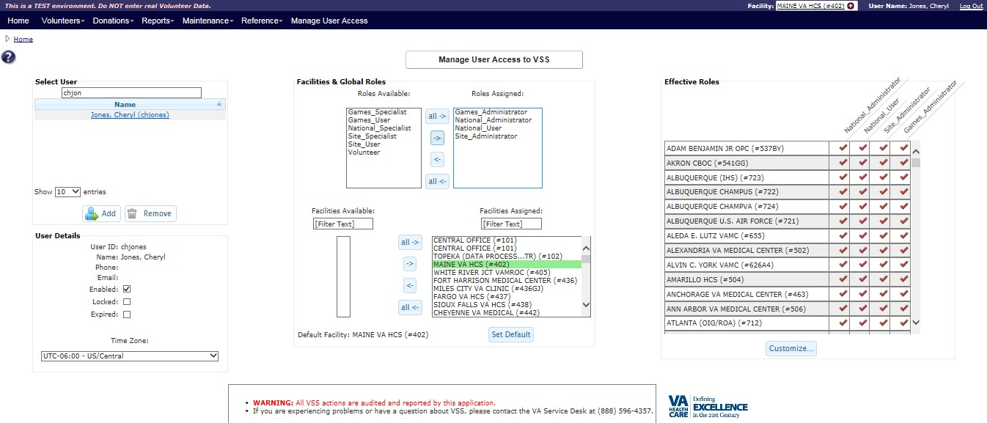

# Help

Click the **Help** icon in the VSS application to view additional information about the screen.

# Troubleshooting

If screen display issues occur when working in VSS Web, enable Compatibility Mode in the browser. This issue may occur when using Internet Explorer browsers.

To manually enable the setting:

1. Open VSS in Internet Explorer.
2. Click the **Tools** option.
3. Click **Compatibility View Settings** underAdd this Website.
4. Add the VSS Web URL site to the list.
5. Click **Add.**

## Special Instructions for Error Correction

If the application displays an error at the time of log on or if there are error messages that are **NOT** part of data entry (e.g., a system error message), contact the VA Service Desk to log a Remedy ticket. Technical Personnel provides content for error messages with the system.

o Call 1-888-596-4357

o Email [VASD@va.gov](mailto:VASD@va.gov)

Refer to the next **Figure** for an example of an error message. **“Attention”** displays on the screen.

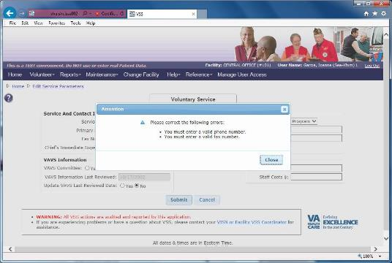

# Acronyms and Abbreviations

|  |  |
| --- | --- |
| **Acronyms & Abbreviations** | **Translation** |
| **ACK** | Acknowledgement |
| **BRD** | Business Requirements Document |
| **CBOCs** | Community Based Outpatient Clinci |
| **CO** | Central Office |
| **COOP** | Continuity of Operation |
| **EO** | Enterprise Operations |
| **IC** | Identifying Code |
| **LDAP** | Lightweight Directory Access Protocol |
| **NAC** | National Advisory Committee |
| **OI&T** | Office of Information and Technology |
| **PMAS** | Project Management Accountability System |
| **SME** | Subject Matter Expert |
| **SQL** | Structured Query Language |
| **TBD** | To Be Delivered |
| **TSPR** | Technical Service Project Repository |
| **UI** | User Interface |
| **VA** | Department of Veterans Affairs |
| **VAVS** | Department of Veterans Affairs (VA) Voluntary Service |
| **VHA** | Veterans Health Administration |
| **VISN** | Veterans Integrated Service Network |
| **Vista** | Veterans Health Information Systems and Technology Architecture |
| **VSS** | Voluntary Service System |

# CRUD Matrix

The CRUD Matrix only applies to the VAVS Staff application and not to actual volunteers.



# Appendix A: Stakeholders, Users, and Workgroups

|  |  |  |
| --- | --- | --- |
| **Type of Stakeholder** | **Description** | **Responsibilities** |
| Requester | Sabrina C. Clark Director, VAVS Office | Submitted request. Submits business requirements; monitors progress of request; contributes to BRD development. |
| Endorser | Lisa Thomas Chief of Staff, Undersecretary for Health | Endorsed this request. Provides strategic direction to the program; elicits executive support and funding; and monitors the progress and timelines. |
| Business Owner/Program Office | Sabrina C. Clark Director, VAVS Office | Provides final approval of BRD with sign-off authority. Provides strategic direction to the program; elicits executive support and funding; and monitors the progress and timelines. |
| Business Subject Matter Expert (SME) | Virginia Hoover Voluntary Service Specialist  VACO,  Washington, DC | Provides background on current system and processes. Describes features of current system, including known problems; and identifies features of enhancements. |
| Technical SME | Richard LeBlanc Project Manager, VistA Migration | Provides technical background information about the current software and requested enhancements. |
| User SME’s | Edmund (Fred) Lesinski Voluntary Services  Yvette Cintron Voluntary Services | Ensures that the enhancements account for current business processes and existing software capabilities. |